ANNEX I

SUMMARY OF PRODUCT CHARACTERISTICS
This medicinal product is subject to additional monitoring. This will allow quick identification of new safety information. Healthcare professionals are asked to report any suspected adverse reactions. See section 4.8 for how to report adverse reactions.

NAME OF THE MEDICINAL PRODUCT

Myalepta 3 mg powder for solution for injection.
Myalepta 5.8 mg powder for solution for injection.
Myalepta 11.3 mg powder for solution for injection.

- QUALITATIVE AND QUANTITATIVE COMPOSITION

Myalepta 3 mg powder for solution for injection
Each vial contains 3 mg of metreleptin*.

After reconstitution with 0.6 mL water for injections (see section 6.6), each mL contains 5 mg of metreleptin.

Myalepta 5.8 mg powder for solution for injection
Each vial contains 5.8 mg of metreleptin*.

After reconstitution with 1.1 mL water for injections (see section 6.6), each mL contains 5 mg of metreleptin.

Myalepta 11.3 mg powder for solution for injection
Each vial contains 11.3 mg of metreleptin*.

After reconstitution with 2.2 mL water for injections (see section 6.6), each mL contains 5 mg of metreleptin.

*Metreleptin is a recombinant human leptin analogue (produced in Escherichia coli cells by recombinant DNA technology to form recombinant methionyl-human leptin).

For the full list of excipients, see section 6.1.

- PHARMACEUTICAL FORM

Powder for solution for injection (powder for injection).

White lyophilised cake or powder.

- CLINICAL PARTICULARS

  - Therapeutic indications

Myalepta is indicated as an adjunct to diet as a replacement therapy to treat the complications of leptin deficiency in lipodystrophy (LD) patients:
- with confirmed congenital generalised LD (Berardinelli-Seip syndrome) or acquired generalised LD (Lawrence syndrome) in adults and children 2 years of age and above
- with confirmed familial partial LD or acquired partial LD (Barraquer-Simons syndrome), in adults and children 12 years of age and above for whom standard treatments have failed to achieve adequate metabolic control.

  - Posology and method of administration

Treatment should be initiated and monitored by a healthcare professional experienced in the diagnosis and management of metabolic disorders.

Posology

The recommended daily dose of metreleptin is based on body weight as provided in Table 1.

In order to ensure patients and carers understand the correct dose to be injected, the prescriber should prescribe the appropriate dose both in milligrams and the volume in millilitres. In order to avoid medication errors including overdose, dose calculation and dose adjustment guidelines below should be followed. A review of the patient’s self-administration technique is recommended every 6 months whilst using Myalepta.

Actual body weight at initiation of treatment should always be used when calculating the dose.

Table 1 Metreleptin recommended dose
Baseline weight | Starting daily dose  (injection volume) | Dose adjustments  (injection volume) | Maximum daily dose  (injection volume)
Males and females ≤ 40 kg | 0.06 mg/kg  (0.012 mL/kg) | 0.02 mg/kg  (0.004 mL/kg) | 0.13 mg/kg  (0.026 mL/kg)
Males > 40 kg | 2.5 mg  (0.5 mL) | 1.25 mg (0.25 mL) to  2.5 mg (0.5 mL) | 10 mg  (2 mL)
Females > 40 kg | 5 mg  (1 mL) | 1.25 mg (0.25 mL) to  2.5 mg (0.5 mL) | 10 mg  (2 mL)

Dose adjustments

Based on clinical response (e.g. inadequate metabolic control) or other consideration (e.g. tolerability issues, excessive weight loss especially in paediatric patients), the dose may be decreased, or increased to the maximum dose listed in Table 1. The maximum tolerated dose may be less than the maximum daily dose, outlined in Table 1, as evidenced by excessive weight loss, even if metabolic response is incomplete.

A minimum clinical response is defined as at least:
- 0.5% HbA1c reduction and/or 25% reduction in insulin requirements
and / or
- 15% reduction in triglycerides (TGs)

If clinical response is not seen after 6 months of treatment the physician should ensure that the patient is compliant with the administration technique, is receiving the correct dose and is adherent to diet. Consider dose increase before stopping treatment.
Metreleptin dose increases in adults and children based on incomplete clinical response can be considered after a minimum of 6 months of treatment, allowing for lowering concomitant insulin, oral anti-diabetic and/or lipid lowering medication.

Reductions in HbA1c and TG may not be seen in children as metabolic abnormalities may not be present at the start of treatment. It is anticipated that most children will require increasing per kg dose, especially as they reach puberty. Increasing abnormalities of TG and HbA1c may be seen which may require a dose increase. Dose adjustments in children without metabolic abnormalities should primarily be made according to weight change.

Dose increases should not be made more frequently than every 4 weeks. Dose decreases based on weight loss may be made weekly.

There is a risk of hypoglycaemia in patients treated with Myalepta who are on anti-diabetic therapy. Large dose reductions of 50% or more of baseline insulin requirements may be needed in the initial phases of treatment. Once insulin requirements have stabilised, dose adjustments of other anti-diabetic therapies may also be needed in some patients to minimise the risk of hypoglycaemia (see section 4.4 and 4.8).

Discontinuation in patients at risk for pancreatitis

When discontinuing Myalepta in patients with risk factors for pancreatitis (e.g. history of pancreatitis, severe hypertriglyceridaemia), tapering of the dose over a two-week period is recommended in conjunction with a low-fat diet. During tapering, monitor triglyceride levels and consider initiating or adjusting the dose of lipid-lowering medicinal products as needed. Signs and/or symptoms consistent with pancreatitis should prompt an appropriate clinical evaluation (see section 4.4).

Missed dose

If a patient misses a dose, the dose should be administered as soon as the omission is noticed and the normal dosing schedule resumed the next day.

Special populations

Elderly

Clinical trials of metreleptin did not include sufficient numbers of patients aged 65 and older to determine whether they respond differently from younger patients. In general, dose selection and modification for an elderly patient should be cautious, although no specific dose adjustment is recommended.

Renal and hepatic impairment

Metreleptin has not been studied in patients with impaired renal or hepatic function. No dose recommendations can be made.

Paediatric population

The safety and efficacy of metreleptin in children aged 0 to 2 years with generalised LD and children aged 0 to 12 years with partial LD has not been established. Very limited data are available for children, especially less than 6 years, with generalised LD.

Method of administration

Subcutaneous use.

Healthcare professionals should provide patients and carers with training on the reconstitution of the product and proper subcutaneous injection technique, so as to avoid intramuscular injection in patients with minimal subcutaneous adipose tissue.

Patients and/or carers should prepare and administer the first dose of the medicinal product under the supervision of a qualified healthcare professional.

The injection should be administered at the same time every day. It can be administered any time of the day without regard to the timing of meals.

The reconstituted solution should be injected into the abdomen, thigh or upper arm tissue. It is recommended that patients should use a different injection site each day when injecting in the same region. Doses exceeding 1 mL can be administered as two injections (the total daily dose divided equally) to minimise potential injection site discomfort due to injection volume. When dividing doses due to volume, doses can be administered one after the other at different injection sites.

When small doses/volumes are prescribed (e.g. in children), the vials will remain almost completely filled with product after withdrawal of the required dose. Remaining reconstituted product should be discarded after use.

For instructions on reconstitution of the medicinal product before administration, see section 6.6 and the information intended for patients in the package leaflet (section 7).

Table 2 Dose calculation
Weight and gender | Starting dose calculation
For males and females ≤ 40 kg once daily dose | Weight (kg) x 0.06 mg/kg = Individual patient daily starting dose in mg  Weight (kg) x 0.012 mL/kg = Individual patient daily starting volume to inject in mL  Example:  25 kg patient is initiated at 0.06 mg/kg of Myalepta. The individual patient dose = 1.5 mg  25 kg patient is initiated at 0.012 mL/kg = 0.3 mL of Myalepta solution to inject
For males > 40 kg once daily dose | Individual patient once daily dose in mg = 2.5 mg  Amount to inject once daily dose = 0.5 mL
For females > 40 kg once daily dose | Individual patient once daily dose in mg = 5 mg  Amount to inject once daily dose = 1 mL

Table 3 Required syringe for Myalepta reconstitution with water for injection
Syringe | Needle gauge and length
Myalepta 3 mg powder for solution for injection
1.0 mL | 21 gauge  40 mm needle
Myalepta 5.8 mg powder for solution for injection
3.0 mL | 21 gauge  40 mm needle
Myalepta 11.3 mg powder for solution for injection
3.0 mL | 21 gauge  40 mm needle

Table 4 Required administration syringe per Myalepta dose
Syringe | Needle gauge and length | Myalepta dose range to be administered
0.3 mL U100 Insulin Syringe | 31 gauge  8 mm needle | For doses of:  ≤ 1.5 mg /≤ 0.3 mL volume daily
1.0 mL | 30 gauge  13 mm needle | For doses of:  > 1.5 mg - 5 mg / 0.3 - 1.0 mL volume daily
2.5 mL | 30 gauge  13 mm needle | For doses of:  > 5 mg - 10 mg / > 1.0 mL volume daily

For patients weighing less than 40 kg, actual body weight at initiation of therapy should be used to calculate dose; of these, in patients weighing less than or equal to 25 kg, refer to Table 5 for the starting dose.

Table 5 Conversion table for the 0.3 mL U100 insulin syringe
Weight of child | Dose of Myalepta | Actual amount of solution* | Rounded amount of solution | ‘Unit’ measurement volume in 0.3 mL syringe to inject
9 kg | 0.54 mg | 0.108 mL | 0.10 mL | 10
10 kg | 0.60 mg | 0.120 mL | 0.12 mL | 12
11 kg | 0.66 mg | 0.132 mL | 0.13 mL | 13
12 kg | 0.72 mg | 0.144 mL | 0.14 mL | 14
13 kg | 0.78 mg | 0.156 mL | 0.15 mL | 15
14 kg | 0.84 mg | 0.168 mL | 0.16 mL | 16
15 kg | 0.90 mg | 0.180 mL | 0.18 mL | 18
16 kg | 0.96 mg | 0.192 mL | 0.19 mL | 19
17 kg | 1.02 mg | 0.204 mL | 0.20 mL | 20
18 kg | 1.08 mg | 0.216 mL | 0.21 mL | 21
19 kg | 1.14 mg | 0.228 mL | 0.22 mL | 22
20 kg | 1.20 mg | 0.240 mL | 0.24 mL | 24
21 kg | 1.26 mg | 0.252 mL | 0.25 mL | 25
22 kg | 1.32 mg | 0.264 mL | 0.26 mL | 26
23 kg | 1.38 mg | 0.276 mL | 0.27 mL | 27
24 kg | 1.44 mg | 0.288 mL | 0.28 mL | 28
25 kg | 1.50 mg | 0.300 mL | 0.30 mL | 30
*Note: Initial and dose increments should be rounded down to the nearest 0.01 mL

The once daily dose of Myalepta can be increased by increments as shown in Table 6 to a maximum daily dose.

Table 6 Dose adjustment calculation
Adjust dose  as follows  (if necessary) | Action
Males and females ≤ 40 kg | Weight (kg) x 0.02 mg/kg = amount of dose adjustment in mg  Example: A 15 kg patient is initiated at 0.06 mg/kg of Myalepta. The individual patient dose = 0.9 mg. A dose increment of 0.02 mg/kg increases the daily dose to 0.08 mg/kg = 1.2 mg. Total daily volume to be injected is total dose in mg/5, in this case it is 1.2 mg/5 = 0.24 mL which equals 24 units on the 0.3 mL insulin syringe.
Both males and females > 40 kg | For all patients weighing more than 40 kg an incremental adjustment increase in daily dose would be 1.25 mg or 0.25 mL injection volume.  Total daily volume to be injected is total dose in mg/5.  Example: A male patient is initiated at 2.5 mg of Myalepta daily. A dose increment of 1.25 mg increases the daily dose to 3.75 mg.  Total daily volume to be injected is 3.75 mg/5 = 0.75 mL.  The maximum daily dose in males and females is 10 mg or 2 mL injection volume

  - Contraindications

Hypersensitivity to the active substance or to any of the excipients listed in section 6.1.

  - Special warnings and precautions for use

Data from clinical trials do not support safety and efficacy in patients with HIV-related LD.

Hypersensitivity reactions

There have been reports of generalised hypersensitivity (e.g. anaphylaxis, urticaria or generalised rash) in patients using Myalepta. Anaphylactic reactions may follow immediately after administration of the medicine. If an anaphylactic reaction or other serious allergic reaction occurs, administration should be permanently discontinued immediately and appropriate therapy initiated.

Acute pancreatitis associated with discontinuation of Myalepta

Non-compliance with, or abrupt discontinuation of, Myalepta may result in worsening hypertriglyceridaemia and associated pancreatitis, particularly in patients with risk factors for pancreatitis (e.g. history of pancreatitis, severe hypertriglyceridaemia) (see section 4.8). If a patient develops pancreatitis whilst being treated with metreleptin, it is advised that metreleptin be continued uninterrupted, as stopping treatment abruptly may exacerbate the condition. If metreleptin must be stopped for any reason, tapering of the dose over a two-week period is recommended in conjunction with a low fat diet, see section 4.2. During tapering, monitor triglyceride levels and consider initiating or adjusting the dose of lipid-lowering medicinal products as needed. Signs and/or symptoms consistent with pancreatitis should prompt an appropriate clinical evaluation.

Hypoglycaemia with concomitant use of insulin and other anti-diabetics

There is a risk of hypoglycaemia in patients treated with Myalepta who are on anti-diabetic medicinal products, in particular insulin or insulin secretagogues (e.g. sulphonylureas). Large dose reductions of 50% or more of baseline insulin requirements may be needed in the first 2 weeks of treatment. Once insulin requirements have stabilised, dose adjustments of other anti-diabetics may also be needed in some patients to minimise the risk of hypoglycaemia.

Closely monitor blood glucose in patients on concomitant insulin therapy, especially those on high doses, or insulin secretagogues and combination treatment. Patients and carers should be advised to be aware of the signs and symptoms of hypoglycaemia.

In clinical studies, hypoglycaemia has been managed with food/drink intake and by modifying the dose of anti-diabetic medicinal product. In case of hypoglycaemic events of a non-severe nature, food intake management may be considered as an alternative to dose-adjustment of anti-diabetics according to the treating physician’s opinion.

Rotation of injection sites is recommended in patients co-administering insulin (or other subcutaneous medicinal products) and Myalepta.

T-cell lymphoma

Cases of T-cell lymphoma (see section 4.8) have been reported while using Myalepta in clinical studies. A causal relationship between the medicinal product treatment and the development and/or progression of lymphoma has not been established.

The benefits and risks of treatment should be carefully considered in patients with acquired generalised LD and/or in patients with significant haematological abnormalities (including leukopenia, neutropenia, bone marrow abnormalities, lymphoma, and/or lymphadenopathy).

Immunogenicity

In clinical trials, antidrug antibodies (ADA) to metreleptin occurred very commonly (88%) in patients. A blocking activity of the reaction between metreleptin and a recombinant leptin receptor has been observed in vitro in the blood of the majority of patients but the impact on the efficacy of metreleptin could not be clearly established (see section 4.8).

In patients with serious and severe infections, continuation of metreleptin should be at the discretion of the prescriber. An association between the development of a blocking activity against metreleptin and serious and severe infections cannot be excluded (see section 4.8).

Though not confirmed in clinical trials, neutralising antibodies could in theory affect the activity of endogenous leptin.

Autoimmune Diseases

Autoimmune disorder progression / flares, including severe autoimmune hepatitis, have been observed in some patients treated with Myalepta but a causal relationship between Myalepta treatment and progression of autoimmune disease has not been established. Close monitoring for underlying autoimmune disorder flares (sudden and severe onset of symptoms) is recommended. The potential benefits and risks of Myalepta treatment should be carefully considered in patients with autoimmune diseases.

Pregnancy

Unplanned pregnancies may occur due to restoration of luteinizing hormone (LH) release, see section 4.6.

Excipients

This medicinal product contains less than 1 mmol sodium (23 mg) per dose, that is to say essentially “sodium free”.

  - Interaction with other medicinal products and other forms of interaction

No interaction studies have been performed in humans.

Leptin is a cytokine and has the potential to alter the formation of cytochrome P450 (CYP450) enzymes. Since it cannot be excluded that metreleptin may reduce exposure to substrates of CYP3A through enzyme induction, the efficacy of hormonal contraceptives may be reduced if co-administered with metreleptin. Therefore, an additional non-hormonal contraceptive method should be considered during treatment. The effect of metreleptin on CYP450 enzymes may be clinically relevant for CYP450 substrates with narrow therapeutic index, where the dose is individually adjusted. Upon initiation or discontinuation of metreleptin, in patients being treated with these types of agents, therapeutic monitoring of effect (e.g., warfarin), or drug concentrations (e.g. cyclosporin or theophylline) should be performed and the individual dose of the agent adjusted as needed. When starting therapy with Myalepta there is a risk of hypoglycaemia in patients who are on anti-diabetic medicinal products, in particular insulin or insulin secretagogues (see section 4.4).

  - Fertility, pregnancy and lactation

Pregnancy

Myalepta is not recommended during pregnancy and in women of childbearing potential not using contraception. Abortions, stillbirths and preterm deliveries have been reported in women exposed to metreleptin during pregnancy, though there is currently no evidence to suggest a causal relationship with the treatment. Studies in animals have shown some evidence of reproductive toxicity (see section 5.3).

Breast-feeding

It is unknown whether metreleptin or its metabolites are excreted in human milk. Endogenous leptin is present in human milk.

A risk to newborns/infants cannot be excluded.

A decision must be made whether to discontinue breast-feeding or to discontinue/abstain from Myalepta therapy, taking into account the benefit of breast-feeding for the child and the benefit of therapy for the woman.

Fertility

There are data to suggest metreleptin may increase fertility, due to effects on LH, with the consequent potential for unplanned pregnancy (see section 4.4).

Animal studies showed no adverse effects on male or female fertility (see section 5.3).

  - Effects on ability to drive and use machines

Myalepta has minor influence on the ability to drive and use machines due to fatigue and dizziness.

  - Undesirable effects

Summary of the safety profile

A total of 148 patients with generalised and partial LD received metreleptin during clinical studies.

Safety and efficacy data were analysed in a subgroup of partial LD patients with the following characteristics: 12 years of age and above with leptin levels < 12 ng/mL, TG ≥ 5.65 mmol/l and/or HbA1c ≥ 8%.

The adverse reactions reported in generalised LD and this subgroup of partial LD patients are listed in Table 7. Additionally, adverse reactions from post-marketing sources are also presented. The most frequently occurring adverse reactions from the clinical studies were hypoglycaemia (14%) and weight decreased (17%).

Tabulated list of adverse reactions

Adverse reactions are classified by MedDRA System Organ Class and absolute frequency in Table 7. Frequencies are defined as very common (≥ 1/10); common (≥ 1/100 to < 1/10); uncommon (≥ 1/1,000 to < 1/100); rare (≥ 1/10,000 to < 1/1,000); very rare (< 1/10,000); not known (cannot be estimated from available data). Due to the number of patients with generalised and partial LD treated in clinical trials, it is not possible to detect with certainty, events which occur at a frequency of < 1%.

Table 7 Adverse reactions reported with Myalepta in > 1 patient during clinical studies in generalised LD and the subgroup of partial LD patients and post-marketing experience
System Organ Class | Very common | Common | Frequency not known*
Infections and infestations |  |  | Influenza, Pneumonia
Immune system disorders |  |  | Anaphylactic reaction
Metabolism and nutrition disorders | Hypoglycaemia | Decreased appetite | Diabetes mellitus, Hyperphagia, Insulin resistance
Nervous system disorders |  | Headache
Cardiac disorders |  |  | Tachycardia
Vascular disorders |  |  | Deep vein thrombosis
Respiratory, thoracic and mediastinal disorders |  |  | Cough, Dyspnoea Pleural effusion
Gastrointestinal disorders |  | Abdominal pain, Nausea | Abdominal pain upper, Diarrhoea, Pancreatitis, Vomiting
Skin and subcutaneous tissue disorders |  | Alopecia | Pruritus, Rash, Urticaria
Musculoskeletal and connective tissue disorders |  |  | Arthralgia, Myalgia
Reproductive system and breast disorders |  | Menorrhagia
General disorders and administration site conditions |  | Fatigue, Injection site bruising, Injection site erythema, Injection site reaction | Fat tissue increased, Injection site haemorrhage, Injection site pain, Injection site pruritus, Injection site swelling, Malaise, Peripheral swelling
Investigations | Weight decreased | Neutralising antibodies | Blood glucose abnormal, Blood triglycerides increased, Drug specific antibody present, Glycosylated haemoglobin increased, Weight increased
*Global post marketing experience

Acute pancreatitis associated with discontinuation of metreleptin

In clinical studies, 6 patients (4 with generalised LD and 2 with partial LD), experienced treatment-emergent pancreatitis. All patients had a history of pancreatitis and hypertriglyceridaemia. Abrupt interruption and/or non-compliance with metreleptin dosing was suspected to have contributed to the occurrence of pancreatitis in 2 patients. The mechanism for pancreatitis in these patients was presumed to be return of hypertriglyceridaemia and therefore increased risk of pancreatitis in the setting of discontinuation of effective therapy for hypertriglyceridaemia.

Hypoglycaemia

Metreleptin may decrease insulin resistance in diabetic patients, resulting in hypoglycaemia in patients with LD and co-existing diabetes. Hypoglycaemia, deemed as related to metreleptin treatment, occurred in 14.2% of patients studied. All reports of hypoglycaemia in patients with generalised LD and in the subgroup of partial LD patients, have been mild in nature with no pattern of onset or clinical sequelae. Generally the majority of events could be managed by food intake with only relatively few modifications of anti-diabetic medicinal product dose occurring.

T-cell lymphoma

Three cases of T-cell lymphoma have been reported while using metreleptin in clinical studies. All three patients had acquired generalised LD. Two of these patients were diagnosed with peripheral T-cell lymphoma while receiving the medicinal product. Both had immunodeficiency and significant haematological abnormalities including severe bone marrow abnormalities before the start of treatment. A separate case of anaplastic large cell lymphoma was reported in a paediatric patient receiving the medicinal product who did not have haematological abnormalities before treatment.

Immunogenicity

In clinical trials (Studies NIH 991265/20010769 and FHA101), the rate of ADAs for generalised LD and the partial LD patients studied and with data available were 88% (65 out of 74 patients). A blocking activity of the reaction between metreleptin and a recombinant leptin receptor has been observed in vitro in the blood of the majority of an extended set of patients (98 out of 102 patients or 96%) but the impact on the efficacy of metreleptin could not be clearly established.
Serious and/or severe infections that were temporally associated with > 80% blocking activity against metreleptin occurred in 5 generalised LD patients. These events included 1 episode in 1 patient of serious and severe appendicitis, 2 episodes in patients of serious and severe pneumonia, a single episode of serious and severe sepsis and non-serious severe gingivitis in 1 patient and 6 episodes of serious and severe sepsis or bacteraemia and 1 episode of non-serious severe ear infection in 1 patient. One serious and severe infection of appendicitis was temporally associated with blocking activity against metreleptin in a patient with partial LD who was not in the subgroup of partial LD patients. Though temporally associated, it is not possible to unequivocally confirm or deny a direct relation to metreleptin treatment based on the currently available body of evidence. LD patients with a blocking activity against metreleptin and concurrent infections responded to standard of care treatment (see section 4.4).

Injection site reactions

Injection site reactions were reported in 3.4% of patients with LD treated with metreleptin. All events reported in clinical studies in patients with LD have been mild or moderate in severity and none have led to treatment discontinuation. Most events occurred during the initial 1-2 months of initiation of treatment.

Paediatric population

Across two completed clinical studies (NIH 991265/20010769 and FHA101), there were 52 paediatric patients (4 in the subgroup of partial LD patients and 48 with generalised LD) enrolled and exposed to metreleptin. Limited clinical data exists in children less than 2 years old for generalised LD patients and less than 12 years old in partial LD patients.

Overall, the safety and tolerability of metreleptin are similar in children and adults.

In generalised LD patients, the overall incidence of adverse reactions was similar regardless of age. Serious adverse reactions were reported in 2 patients, worsening hypertension and anaplastic large cell lymphoma.

In partial LD patients, assessment across age groups is limited, due to the small sample size. No adverse reactions were reported in paediatric patients in the subgroup of partial LD patients.

Reporting of suspected adverse reactions
Reporting suspected adverse reactions after authorisation of the medicinal product is important. It allows continued monitoring of the benefit/risk balance of the medicinal product. Healthcare professionals are asked to report any suspected adverse reactions via the national reporting system listed in Appendix V.

  - Overdose

In one post-marketing case, an infant was exposed to a 10-fold overdose of metreleptin for 8 months. In this case, prolonged overdose was associated with severe anorexia causing vitamin and zinc deficiencies, iron deficiency anaemia, protein calorie malnutrition, and poor weight gain, which resolved following supportive treatment and dose adjustment.

In case of overdose, patients should be closely monitored for signs or symptoms of adverse reactions and supportive treatment initiated.

- PHARMACOLOGICAL PROPERTIES

  - Pharmacodynamic properties

Pharmacotherapeutic group: Other alimentary tract and metabolism products, amino acids and derivatives, ATC code: A16AA07

Mechanism of action

Metreleptin mimics the physiological effects of leptin by binding to and activating the human leptin receptor, which belongs to the Class I cytokine family of receptors that signals through the JAK/STAT transduction pathway.

Only the metabolic effects of metreleptin have been studied. No effects on the distribution of subcutaneous fat are expected.

Clinical efficacy and safety

The efficacy and safety of treatment with metreleptin was evaluated in an open-label, single-arm study (Study NIH 991265/20010769) in patients with congenital or acquired generalised LD or familial or acquired partial LD. Patients were eligible for inclusion if they were > 6 months old, with a leptin level of < 12 ng/mL, and had at least 1 of the following 3 metabolic abnormalities:
- Presence of diabetes mellitus, or
- Fasting insulin concentration > 30 μU/mL, or
- Fasting TG concentration > 2.26 mmol/L or postprandially elevated triglycerides > 5.65 mmol/L

The co-primary efficacy endpoints in this study were defined as:
- Actual change from baseline in HbA1c at Month 12, and
- Percent change from baseline in fasting serum TGs at Month 12

Study NIH 991265/20010769 was conducted over 14 years, with the primary efficacy assessments being made in both generalised LD and partial LD patients after 12 months of treatment. Multiple dosing regimens were explored during the NIH study, which led to the posology recommended in section 4.2.

Concomitant anti-diabetic and lipid-lowering dose regimens were not held constant during the study, but analyses showed no significant difference in efficacy between patients who had no increases or additions to their anti-diabetic or lipid-lowering treatments versus the overall study population.

Generalised LD

Of the 66 generalised LD patients enrolled, 45 (68%) had congenital generalised LD and 21 (32%) had acquired generalised LD. Overall, 51 (77%) patients were female, 31 (47%) were Caucasian, 11 (17%) Hispanic, and 16 (24%) Black. The median age at baseline was 15 years (range: 1–68 years), with 45 (68%) patients being less than 18 years of age. The median fasting leptin concentration at baseline was 1.0 ng/mL in males (range: 0.3–3.3 ng/mL) and 1.1 ng/mL in females (range: 0.2-5.3 ng/mL) using the LINCO RIA test method.

The median duration of metreleptin treatment was 4.2 years (range: 3.4 months–13.8 years). The medicinal product was administered subcutaneously either once daily or twice daily (in two equal doses). The weighted average daily dose (i.e., the average dose taking into account duration of treatment at different doses) for the 48 patients with baseline body weight greater than 40 kg was 2.6 mg for males and 5.2 mg for females during the first year of treatment, and 3.7 mg for males and 6.5 mg for females over the entire study period. For the 18 patients with baseline body weight less than or equal to 40 kg, the weighted average daily dose was 2.0 mg for males and 2.3 mg for females in the first year of treatment, and 2.5 mg for males and 3.2 mg for females over the entire study period.

Table 8 Primary outcome results in an open-label, single-arm study (NIH 991265/20010769) in evaluable patients with generalised LD treated with metreleptin at 12 months
Parameter | n | Baseline | Change from Baseline at Month 12
HbA1c (%) | 59
Mean (SD) |  | 8.6 (2.33) | -2.2 (2.15)
P |  |  | < 0.001
Fasting TGs (mmol/L) | 58
Mean (SD) |  | 14.7 (25.6) | -32.1% (71.28)
P |  |  | 0.001
SD = standard deviation

Among 45 patients with generalised LD who had a baseline HbA1c of 7% or greater and data available at Month 12, the mean (SD) baseline HbA1c was 9.6% (1.63) and the mean reduction in HbA1c at Month 12 was 2.8%. Among 24 patients with generalised LD who had a baseline TG level 5.65 mmol/l or greater and data available at Month 12, the mean (SD) baseline TG level was 31.7 mmol/l (33.68) and the mean percent reduction in triglycerides at Month 12 was 72%.

Among the 39 patients with generalised LD who were receiving insulin at baseline, 16 (41%) were able to discontinue insulin use altogether after starting metreleptin. Most of these patients (13 of 16) were able to stop insulin use within the first year of metreleptin. For the 32 patients with generalised LD who were receiving oral anti-diabetic medicinal products at baseline, 7 (22%) were able to discontinue their use. A total of 8 (24%) of the 34 patients with generalised LD who were receiving lipid-lowering therapies at baseline discontinued their use during metreleptin treatment.

There was evidence of improvement in renal and hepatic function in patients with generalised LD treated with metreleptin. In 24 patients with renal data available, the mean change at Month 12 in protein excretion rate versus baseline (1,675.7 mg/24hr) was -906.1 mg/24 hr. In 43 patients with hepatic data available, the mean changes at Month 12 in alanine aminotransferase, versus baseline (112.5 U/L) was -53.1 U/L, and aspartate aminotransferase versus baseline (75.3 U/L) was -23.8 U/L.

Partial LD subgroup

A subgroup of partial LD patients is analysed for whom TG ≥ 5.65 mmol/l and/or HbA1c ≥ 6.5% at baseline. Of the 31 partial LD subgroup patients evaluated, 27 (87%) had familial partial LD and 4 (13%) had acquired partial LD. Overall, 30 (97%) patients were female, 26 (84%) were Caucasian, 2 (7%) Hispanic, and 0 Black. The median age at baseline was 38 years (range: 15-64 years), with 5 (16%) patients being less than 18 years of age. The median fasting leptin concentration at baseline was 5.9 ng/mL (1.6-16.9) using the LINCO RIA test method.

The median duration of metreleptin treatment was 2.4 years (range: 6.7 months-14.0 years). The medicinal product was administered subcutaneously either once daily or twice daily (in two equal doses). The weighted average daily dose (i.e., the average dose taking into account duration of treatment at different doses) for all 31 patients with baseline body weight greater than 40 kg was 7.0 mg during the first year of treatment, and 8.4 mg over the entire study period.

Table 9 Primary outcome results in study (NIH 991265/ 20010769) of evaluable patients in the partial LD subgroup treated with metreleptin at 12 months
Parameter | n | Baseline | Change from Baseline at Month 12
HbA1c (%) | 27
Mean (SD) |  | 8.8 (1.91) | -0.9 (1.23)
P |  |  | < 0.001
Fasting Triglycerides (mmol/L) | 27
Mean (SD) |  | 15.7 (26.42) | -37.4% (30.81)
P |  |  | < 0.001
SD = standard deviation

Among 15 patients in the partial LD subgroup who had a baseline TG level 5.65 mmol/L or greater and data available at Month 12, the mean (SD) baseline triglyceride level was 27.6 mmol/L (32.88) and the mean percent reduction in TGs at Month 12 was 53.7%.

Among 18 patients in the partial LD subgroup who had a baseline HbA1c level 8% or greater and data available at Month 12, the mean (SD) baseline HbA1c level was 9.9% (1.59) and the mean reduction in HbA1c at Month 12 was 1.3%.

Paediatric population

In the generalised LD group, the number of patients according to age group was as follows: 5 patients < 6 years (including a single patient < 2 years), 12 patients ≥ 6 to < 12 years and 28 patients aged ≥ 12 to < 18 years; in the partial LD subgroup, there were no patients < 12 years of age and 4 patients ≥ 12 to < 18 years.

In the generalised LD group, mean decreases from baseline in HbA1c were noted in all age groups ≥ 6 years; the mean decreases to Month 12/last observation carried forward LOCF were similar in the two older age groups (-1.1% and -2.6%). Mean change among the 5 patients < 6 years of age was 0.2%. These differences across age groups are likely related to differences in mean HbA1c at baseline, which was in the normal range for patients < 6 years (5.7%) and lower in patients ≥ 6 to < 12 years (6.4%) compared to the older age group (9.7%). Mean decreases from baseline to Month 12/LOCF in TGs for the generalised LD group were noted in all age groups with larger mean changes observed in the older age group (-42.9%) compared to the younger age groups (-10.5% and -14.1%).

Among the 4 patients in the partial LD subgroup between 12 and 18 years of age, mean change to Month 12/LOCF for HbA1c was -0.7% and for TGs was -55.1%.

The European Medicines Agency has deferred the obligation to submit the results of studies with Myalepta in one or more subsets of the paediatric population in the treatment of lipodystrophy (see section 4.2 for information on paediatric use).

This medicinal product has been authorised under ‘exceptional circumstances’. This means that due to the rarity of the disease it has not been possible to obtain complete information on this medicinal product.

The European Medicines Agency will review any new information which may become available every year and this SmPC will be updated as necessary.

  - Pharmacokinetic properties

There are limited data on the pharmacokinetics of metreleptin in patients with lipodystrophy and therefore no formal exposure-response analysis has been performed.

Absorption

Peak serum leptin (endogenous leptin and metreleptin) concentration (C_{max}) occurred approximately 4.0 hours after subcutaneous administration of single doses ranging from 0.1 to 0.3 mg/kg in healthy adult subjects. In a supportive trial in LD patients, the median T_{max} was 4 hours (range: 2 to 6 hours; N = 5) following single-dose administration of metreleptin.

Distribution

In studies of healthy adult subjects, following intravenous administration of metreleptin, leptin volume of distribution (endogenous leptin and metreleptin) was approximately 4 to 5 times plasma volume; volumes (mean ± SD) were 370 ± 184 mL/kg, 398 ± 92 mL/kg, and 463 ± 116 mL/kg for 0.3, 1.0, and 3.0 mg/kg/day doses, respectively.

Biotransformation

No formal metabolism studies have been conducted.

Elimination

Non-clinical data indicate renal clearance is the major route of metreleptin elimination, with no apparent contribution of systemic metabolism or degradation. Following single subcutaneous doses of 0.01 to 0.3 mg/kg metreleptin in healthy adult subjects, the half-life was 3.8 to 4.7 hours. After IV administration, metreleptin clearance was shown to be 79.6 mL/kg/h in healthy volunteers. The clearance of metreleptin appears to be delayed in the presence of ADAs. A higher accumulation is observed with higher ADA levels. Dose adjustments should be made based on clinical response (see section 4.4).

Pharmacokinetics in special populations

Hepatic Impairment

No formal pharmacokinetic studies were conducted in patients with hepatic impairment.

Renal Impairment

No formal pharmacokinetic studies were conducted in patients with renal impairment. Non-clinical data indicate renal clearance is the major route of metreleptin elimination, with no apparent contribution of systemic metabolism or degradation. Hence, the pharmacokinetics may be altered in patients with renal impairment.

Age, Gender, Race, Body Mass Index

Specific clinical studies have not been conducted to assess the effect of age, gender, race, or body mass index on the pharmacokinetics of metreleptin in patients with lipodystrophy.

  - Preclinical safety data

Non-clinical data based on conventional studies of safety pharmacology, repeated dose toxicity and genotoxicity reveal no risks additional to those attributed to an excess of the expected pharmacodynamic responses, such as loss of appetite and body weight.

Two-year carcinogenicity studies in rodents have not been conducted. Metreleptin exhibits no genotoxic potential and no proliferative or preneoplastic lesions were observed in mice or dogs following treatment up to 6 months.

Reproductive toxicity studies conducted in mice have revealed no adverse effects on mating, fertility or embryo-foetal development up to the maximum tested dose, approximately, 15-fold the maximum recommended clinical dose, based on body surface area of a 60 kg patient.

In a pre- and postnatal development study in mice, metreleptin caused prolonged gestation and dystocia at all tested doses, starting at, approximately, a dose identical to the maximum recommended clinical dose, based on body surface area of a 60 kg patient. Prolonged gestation resulted in the death of some females during parturition and lower survival of offspring within the immediate postnatal period. These findings are considered to be related indirectly to metreleptin pharmacology, resulting in nutritional deprivation of treated animals, and also possibly, due to an inhibitory effect on spontaneous and oxytocin-induced contractions, as has been observed in strips of human myometrium exposed to leptin. Decreased maternal body weight was observed from gestation throughout lactation at all doses and resulted in reduced weight of offspring at birth, which persisted into adulthood. However, no developmental abnormalities were observed and reproductive performance of the first or second generations was not affected at any dose.

Reproductive toxicity studies have not included toxicokinetics analysis. However, separate studies revealed that exposure of the mouse foetus to metreleptin was low (< 1%) after subcutaneous administration of metreleptin to pregnant mice. The AUC exposure of pregnant mice was approximately 2 to 3 times greater than observed in non-pregnant mice after 10 mg/kg subcutaneous administration of metreleptin. A 4 to 5-fold increase in the t_{1/2} values was also observed in pregnant mice compared to non-pregnant mice. The greater metreleptin exposure and longer t_{1/2} observed in the pregnant animals may be related to a reduced elimination capacity by binding to soluble leptin receptor found at higher levels in pregnant mice.

No studies with direct administration of metreleptin to juvenile animals have been conducted. However, in published studies, leptin treatment of euleptinaemic prepubertal female mice has led to an earlier onset of puberty.

- PHARMACEUTICAL PARTICULARS

  - List of excipients

Glycine
Sucrose
Polysorbate 20
Glutamic acid
Sodium Hydroxide (for pH adjustment)

  - Incompatibilities

In the absence of compatibility studies, this medicinal product must not be mixed with other medicinal products, except those mentioned in section 6.6.

  - Shelf life

3 years.

Following reconstitution with water for injections, the medicinal product must be used immediately and cannot be stored for future use.

  - Special precautions for storage

Store in a refrigerator (2 °C–8 °C). Keep the vial in the outer carton in order to protect from light.

For storage conditions after reconstitution of the medicinal product, see section 6.3.

  - Nature and contents of container

Myalepta 3 mg powder for solution for injection
Type I glass vial (3 mL) with a chlorobutyl rubber stopper and an aluminium seal/red plastic flip-off cap.

Myalepta 5.8 mg powder for solution for injection
Type I glass vial (3 mL) with a chlorobutyl rubber stopper and an aluminium seal/blue plastic flip-off cap.

Myalepta 11.3 mg powder for solution for injection
Type I glass vial (5 mL) with a bromobutyl rubber stopper and an aluminium seal/white plastic flip-off cap.

Pack sizes of 1 or 30 vials.

Not all pack sizes may be marketed.

  - Special precautions for disposal and other handling

The patient will receive a carton containing 1 or 30 vials of Myalepta, depending on the pack size, which should be stored in a refrigerator until the day of use.

The patient will also receive separately the solvent for reconstitution (i.e. water for injection), the syringes/needles for reconstitution, the syringes/needles for administration, the cleansing alcohol swabs, and a sharps disposal container.

Instructions for reconstitution

- Remove the vial from the refrigerator and allow the vial to warm for 10 minutes to reach room temperature (20 °C–25 °C) prior to reconstitution.
2. Visually inspect the vial containing the medicinal product. The cake of lyophilised powder should be intact and white in colour.
3. Myalepta 3 mg powder for solution for injection
Using a 1 mL syringe with a 21-gauge or smaller diameter needle, withdraw 0.6 mL of water for injection. Do not reconstitute with other diluents.

Myalepta 5.8 mg powder for solution for injection
Using a 3 mL syringe with a 21-gauge or smaller diameter needle, withdraw 1.1 mL of water for injection. Do not reconstitute with other diluents.

Myalepta 11.3 mg powder for solution for injection
Using a 3 mL syringe with a 21-gauge or smaller diameter needle, withdraw 2.2 mL of water for injection. Do not reconstitute with other diluents.

4. Insert the needle into the vial containing the lyophilized powder, through the centre of the stopper and direct the stream of solvent to the wall of the vial to avoid excessive foaming.
5. Remove the needle and syringe from the vial and gently swirl the contents to reconstitute, until the liquid is clear. Do not shake or vigorously agitate. The reconstituted solution will take less than 5 minutes to become clear. When properly mixed, the Myalepta reconstituted solution should be clear, colourless, and free of clumps or dry powder, bubbles or foam. Do not use the solution if discoloured or cloudy, or if particulate matter remains.
6. After reconstitution, each mL contains 5 mg of metreleptin.
7. For instructions on administration, see section 4.2.

Disposal

Myalepta reconstituted with water for injection is for single use only and should be administered immediately. Unused reconstituted solution cannot be stored for later use. Any unused medicinal product or waste material should be disposed of in accordance with local requirements.

- MARKETING AUTHORISATION HOLDER

Amryt Pharmaceuticals DAC
45 Mespil Road
Dublin 4
Ireland

- MARKETING AUTHORISATION NUMBER(S)

Myalepta 3 mg powder for solution for injection

EU/1/18/1276/003
EU/1/18/1276/004

Myalepta 5.8 mg powder for solution for injection

EU/1/18/1276/005
EU/1/18/1276/006

Myalepta 11.3 mg powder for solution for injection

EU/1/18/1276/001
EU/1/18/1276/002

- DATE OF FIRST AUTHORISATION/RENEWAL OF THE AUTHORISATION

Date of first authorisation: 30 July 2018

- DATE OF REVISION OF THE TEXT

Detailed information on this medicinal product is available on the website of the European Medicines Agency http://www.ema.europa.eu.

ANNEX II

A. MANUFACTURER OF THE BIOLOGICAL ACTIVE SUBSTANCE AND MANUFACTURERS RESPONSIBLE FOR BATCH RELEASE

B. CONDITIONS OR RESTRICTIONS REGARDING SUPPLY AND USE

C. OTHER CONDITIONS AND REQUIREMENTS OF THE MARKETING AUTHORISATION

D. conditions or restrictions with regard to the safe and effective use of the medicinal product

E. SPECIFIC OBLIGATION TO COMPLETE POST-AUTHORISATION MEASURES FOR THE MARKETING AUTHORISATION UNDER EXCEPTIONAL CIRCUMSTANCES

- MANUFACTURER OF THE BIOLOGICAL ACTIVE SUBSTANCE AND MANUFACTURERS RESPONSIBLE FOR BATCH RELEASE

Name and address of the manufacturer of the biological active substance
Sandoz GmbH - BP Kundl
Biochemiestrasse 10
6250 Kundl
Austria

Name and address of the manufacturers responsible for batch release
Eurofins PHAST GmbH
Kardinal-Wendel-Straße 16
66424 Homburg
Germany

- CONDITIONS OR RESTRICTIONS REGARDING SUPPLY AND USE

Medicinal product subject to restricted medical prescription (see Annex I: Summary of Product Characteristics, section 4.2).

- OTHER CONDITIONS AND REQUIREMENTS OF THE MARKETING AUTHORISATION

- Periodic Safety Update Reports

The requirements for submission of periodic safety update reports for this medicinal product are set out in the list of Union reference dates (EURD list) provided for under Article 107c(7) of Directive 2001/83/EC and any subsequent updates published on the European medicines web-portal.

The marketing authorisation holder shall submit the first periodic safety update report for this product within 6 months following authorisation.

- CONDITIONS OR RESTRICTIONS WITH REGARD TO THE SAFE AND EFFECTIVE USE OF THE MEDICINAL PRODUCT

- Risk Management Plan (RMP)

The MAH shall perform the required pharmacovigilance activities and interventions detailed in the agreed RMP presented in Module 1.8.2 of the Marketing Authorisation and any agreed subsequent updates of the RMP.

An updated RMP should be submitted:
- At the request of the European Medicines Agency;
- Whenever the risk management system is modified, especially as the result of new information being received that may lead to a significant change to the benefit/risk profile or as the result of an important (pharmacovigilance or risk minimisation) milestone being reached.

- Additional risk minimisation measures

Prior to launch of Myalepta in each Member State the Marketing Authorisation Holder (MAH) must agree about the content and format of the educational programme, including communication media, distribution modalities, and any other aspects of the programme, with the National Competent Authority.
The educational programme is aimed at increasing awareness among healthcare professionals and patients/carers about the important risks contained in the Risk Management Plan. It is also aimed to guide prescribers about the appropriate management of these risks.
The MAH shall ensure that in each Member State where Myalepta is marketed, all healthcare professionals and patients/carers who are expected to use Myalepta are provided with the following educational package:
- Healthcare professionals educational material
- Patients/carers educational material
Healthcare professionals’ educational material should contain:
- The Summary of Product Characteristics
- Guide for healthcare professionals
- Healthcare professionals training material
- A dose card on which the doctor can write for the patient the dose in mg, ml (and where appropriate units from a 0.3 ml U100 insulin syringe). This card will also include pictures of the relevant syringe sizes on which the doctor can draw a line to indicate on the volume of water for injection to use for reconstitution and the volume of reconstituted solution to inject.

The Guide/training material for healthcare professionals shall contain the following key elements:
- Reminders on key prescribing information content, including indicated population, posology, warnings and precautions, and other safety- related information which is key to safe use of the product. This will include for example instructions for handling possible ADRs.
- Responsibility of the prescribing physician to provide appropriate training to the patient/carer who will administer the treatment and that the first dose should be administered in the presence of a doctor or nurse.
- The requirement to perform regular follow-ups with the patient/carer to ensure continued correct and compliant Myalepta reconstitution and treatment.
- Hypersensitivity has been reported with Myalepta use including anaphylaxis, urticaria and generalised rash. If an anaphylactic reaction or other serious allergic reaction occurs, administration of Myalepta should be permanently discontinued immediately and appropriate therapy initiated.
- Non-compliance with or abrupt withdrawal of Myalepta may result in worsening of hypertriglyceridaemia and associated pancreatitis:
  - Risk factors include patients with a history of pancreatitis or severe hypertriglyceridaemia.
  - Tapering the dose over a two-week period is recommended in conjunction with a low fat diet.
  - Patients should be monitored during tapering. Initiating or adjusting lipid lowering medications may be required.
  - Signs and/or symptoms consistent with pancreatitis should prompt an appropriate clinical evaluation.
- Hypoglycaemia with concomitant use of insulin and other antidiabetics may occur:
  - Large dose reductions of 50% or more of baseline insulin requirements may be needed in the first 2 weeks of Myalepta treatment. Once insulin requirements have stabilised, dose adjustments of other anti-diabetics may also be needed in some patients.
  - Monitoring of blood glucose in patients on concomitant insulin therapy, especially those on high doses, or insulin secretagogues and combination treatment is warranted. Patients and carers should be advised to be aware of the signs and symptoms of hypoglycaemia.
  - In case of hypoglycaemic events of a non-severe nature, food intake management may be considered as an alternative to dose adjustment of anti-diabetics.
  - Rotation of injection sites is recommended in patients co administering insulin (or other SC medicinal products) and Myalepta.
- Ways to prevent the occurrence of medication errors
  - Myalepta is administered by SC injection and proper technique should be used to avoid intramuscular injection in patients with minimal SC tissue.
  - HCPs should provide training to patients on the correct technique.
  - Patients and/or caregivers should prepare and administer the first dose under the supervision of a qualified HCP.
  - Detailed instructions for use.
  - Guidance in the educational materials on:
    - The size of syringes and needles to prescribe
    - Prescribing the dose in both mg and ml and, where a 0.3 mL U100 insulin syringe is used, informing patients on the dose in "units" on the syringe to inject
    - The prescribing of ampoule/vial sizes volumes of water for injection in appropriate volumes to reduce the risk of re-use
Pharmacists will be guided in the educational materials on the ancillary items that need to be dispensed to patients including appropriate sized reconstitution and administration syringes and needles, appropriate sized vials/ampoules of water for injection, alcohol swabs and a sharps bin plus how to access Amryt reconstitution and administration kits containing all of the above items except the water for injection and sharps bin.
  - Access to further materials, including training videos in multiple languages that will demonstrate each step to in preparing and administering Myalepta via a website.
- T-cell lymphoma
  - Acquired LDs are associated with autoimmune disorders. Autoimmune disorders are associated with an increased risk of malignancies including lymphomas.
  - Lymphoproliferative disorders, including lymphoma have been reported in patients with acquired generalised LD not treated with Myalepta. Cases of T-cell lymphoma have been reported in clinical studies in patients taking Myalepta. A causal relationship between lymphoma and Myalepta has not been established.
  - The benefits and risks of Myalepta should be carefully considered in patients with acquired LD and/or those with significant haematologic abnormalities (including leukopenia, neutropenia, bone marrow abnormalities, lymphoma and/or lymphadenopathy). An association between the development of Neutralising Antibodies (NAbs) and serious and severe infections cannot be excluded and the continuation of Myalepta should be at the discretion of the prescriber.
- Risk to patients who have or have had autoimmune disease and may have worsening of their symptoms with Myalepta.
- Myalepta may increase fertility, due to effects on LH and thus the chances of unplanned pregnancy. Women of childbearing potential should be advised that Myalepta may increase fertility and should be encouraged to use contraception.
- Neutralising antibodies may develop on Myalepta therapy. An association between the development of neutralising antidrug antibodies and serious and severe infections cannot be excluded, and, continuation of Myalepta should be at the discretion of the prescriber. Consideration should also be given by the prescriber to have patients tested for the presence of neutralising antibodies.
- Loss of efficacy, potentially due to neutralising antibodies, may occur in patients on Myalepta therapy. While the impact of neutralising antibodies on efficacy has not been confirmed, consideration should be given by the prescriber to have patients tested for the presence of neutralising antibodies if there is significant loss of efficacy despite Myalepta administration.
Patients/carers educational material should contain:
- The patient information leaflet
- Guide for patients/carers
- Patients/carers training material
The Guide/training material for patients/carers shall contain the following key elements:
- Reminders on key prescribing information content, including indicated population, posology, warnings and precautions, and other safety- related information which is key to safe use of the product. This will include for example instructions for handling possible ADRs
- Allergic reactions can occur with Myalepta use. Advice will be provided on symptoms of an allergic reaction and action to be taken in the event of such a reaction.
- The need of compliance with treatment due to the risk of pancreatitis when medication is abruptly stopped. The importance of tapering the dose of Myalepta over two weeks if it is to be discontinued.
- Hypoglycaemia with concomitant use of insulin and other antidiabetics may occur.
- The risk of medication error:
  - Responsibility of the prescribing physician to provide appropriate training to the patient/carer who will administer the treatment and that the first dose should be administered in the presence of a doctor or nurse
  - The requirement to perform regular follow-ups with the patient/carer to ensure continued correct and compliant Myalepta reconstitution and treatment
  - Guidance on the appropriate syringe size ancillary administration set to prescribe according to the dosage of Myalepta and how to read the syringe volumes
  - How to access a video on line which shows step by step how to reconstitute, measure the correct dose and administer it subcutaneously
- The association between LD and lymphoma and that the patient will be monitored during treatment.
- Serious and severe infections secondary to the appearance of NAb may occur.
- Risk to patients who have or have had autoimmune disease and may have worsening of their symptoms with Myalepta.
- Myalepta may increase fertility, due to effects on LH and thus the chances of unplanned pregnancy.

- SPECIFIC OBLIGATION TO COMPLETE POST-AUTHORISATION MEASURES FOR THE MARKETING AUTHORISATION UNDER EXCEPTIONAL CIRCUMSTANCES

This being an approval under exceptional circumstances and pursuant to Article 14(8) of Regulation (EC) No 726/2004, the MAH shall conduct, within the stated timeframe, the following measures:

Description | Due date
In order to further evaluate the long-term safety and effectiveness of Myalepta under normal conditions of clinical practice, the applicant should establish a registry including all patients with generalised or partial lipodystrophy treated with Myalepta according to an agreed protocol. | Draft protocol to be submitted 6 months after notification of the European Commission decision  Annual reports to be submitted as part of the annual re-assessment.
In order to further investigate the effect of Myalepta on poor metabolic control once background therapy is maximized in patients with familial or acquired partial LD, the applicant should conduct an efficacy and safety study according to an agreed protocol. | Draft protocol to be submitted 3 months after notification of the European Commission decision.  The final study report should be submitted by 2022.
In order to address the potential safety concerns and/or lack of efficacy related to immunogenicity of Myalepta, the applicant should submit an integrated analysis of immunogenicity measured according to validated assays. The Applicant should conduct this integrated analysis according to an agreed protocol including samples from all available historical samples from previous studies (NIH991265/20010769, FHA 101, NASH4 and obesity studies) with patients with GL/PL and samples obtained from patients that will be included in the efficacy and safety study in PL patients, the paediatric investigational plan (PIP) study and the patients registry. | Draft protocol to be submitted 3 months after notification of the European Commission decision.  The final study report should be submitted by 2024.

ANNEX III

LABELLING AND PACKAGE LEAFLET

A. LABELLING

PARTICULARS TO APPEAR ON THE OUTER PACKAGING

OUTER CARTON

1. NAME OF THE MEDICINAL PRODUCT

Myalepta 3 mg powder for solution for injection
metreleptin

2. STATEMENT OF ACTIVE SUBSTANCE(S)

Each vial contains 3 mg of metreleptin
After reconstitution, each mL contains 5 mg of metreleptin (5 mg/mL)

3. LIST OF EXCIPIENTS

Excipients: glycine, sucrose, polysorbate 20, glutamic acid, sodium hydroxide (for pH adjustment)

4. PHARMACEUTICAL FORM AND CONTENTS

Powder for solution for injection
1 vial
30 vials

5. METHOD AND ROUTE(S) OF ADMINISTRATION

For single use only.

Use only with the solvent for reconstitution, syringes and needles, provided separately.
Unused reconstituted solution should be discarded after use.
Read the package leaflet before use.
Subcutaneous use.

6. SPECIAL WARNING THAT THE MEDICINAL PRODUCT MUST BE STORED OUT OF THE SIGHT AND REACH OF CHILDREN

Keep out of the sight and reach of children.

7. OTHER SPECIAL WARNING(S), IF NECESSARY

8. EXPIRY DATE

EXP
After reconstitution: use immediately.

9. SPECIAL STORAGE CONDITIONS

Store in a refrigerator.

Keep the vial in the outer carton in order to protect from light.

10. SPECIAL PRECAUTIONS FOR DISPOSAL OF UNUSED MEDICINAL PRODUCTS OR WASTE MATERIALS DERIVED FROM SUCH MEDICINAL PRODUCTS, IF APPROPRIATE

Any unused product or waste material should be discarded according to the local requirements.

11. NAME AND ADDRESS OF THE MARKETING AUTHORISATION HOLDER

Amryt Pharmaceuticals DAC
45 Mespil Road
Dublin 4
Ireland

12. MARKETING AUTHORISATION NUMBER(S)

EU/1/18/1276/003

EU/1/18/1276/004

13. BATCH NUMBER

Lot

14. GENERAL CLASSIFICATION FOR SUPPLY

15. INSTRUCTIONS ON USE

16. INFORMATION IN BRAILLE

myalepta 3 mg

17. UNIQUE IDENTIFIER – 2D BARCODE

2D barcode carrying the unique identifier included.

18. UNIQUE IDENTIFIER - HUMAN READABLE DATA

PC
SN
NN

MINIMUM PARTICULARS TO APPEAR ON SMALL IMMEDIATE PACKAGING UNITS

VIAL

1. NAME OF THE MEDICINAL PRODUCT AND ROUTE(S) OF ADMINISTRATION

Myalepta 3 mg powder for injection
metreleptin
Subcutaneous use

2. METHOD OF ADMINISTRATION

3. EXPIRY DATE

EXP

4. BATCH NUMBER

Lot

5. CONTENTS BY WEIGHT, BY VOLUME OR BY UNIT

5 mg/mL

6. OTHER

PARTICULARS TO APPEAR ON THE OUTER PACKAGING

OUTER CARTON

1. NAME OF THE MEDICINAL PRODUCT

Myalepta 5.8 mg powder for solution for injection
metreleptin

2. STATEMENT OF ACTIVE SUBSTANCE(S)

Each vial contains 5.8 mg of metreleptin
After reconstitution, each mL contains 5 mg of metreleptin (5 mg/mL)

3. LIST OF EXCIPIENTS

Excipients: glycine, sucrose, polysorbate 20, glutamic acid, sodium hydroxide (for pH adjustment)

4. PHARMACEUTICAL FORM AND CONTENTS

Powder for solution for injection
1 vial
30 vials

5. METHOD AND ROUTE(S) OF ADMINISTRATION

For single use only.

Use only with the solvent for reconstitution, syringes and needles, provided separately.
Unused reconstituted solution should be discarded after use.
Read the package leaflet before use.
Subcutaneous use.

6. SPECIAL WARNING THAT THE MEDICINAL PRODUCT MUST BE STORED OUT OF THE SIGHT AND REACH OF CHILDREN

Keep out of the sight and reach of children.

7. OTHER SPECIAL WARNING(S), IF NECESSARY

8. EXPIRY DATE

EXP
After reconstitution: use immediately.

9. SPECIAL STORAGE CONDITIONS

Store in a refrigerator.

Keep the vial in the outer carton in order to protect from light.

10. SPECIAL PRECAUTIONS FOR DISPOSAL OF UNUSED MEDICINAL PRODUCTS OR WASTE MATERIALS DERIVED FROM SUCH MEDICINAL PRODUCTS, IF APPROPRIATE

Any unused product or waste material should be discarded according to the local requirements.

11. NAME AND ADDRESS OF THE MARKETING AUTHORISATION HOLDER

Amryt Pharmaceuticals DAC
45 Mespil Road
Dublin 4
Ireland

12. MARKETING AUTHORISATION NUMBER(S)

EU/1/18/1276/005

EU/1/18/1276/006

13. BATCH NUMBER

Lot

14. GENERAL CLASSIFICATION FOR SUPPLY

15. INSTRUCTIONS ON USE

16. INFORMATION IN BRAILLE

myalepta 5.8 mg

17. UNIQUE IDENTIFIER – 2D BARCODE

2D barcode carrying the unique identifier included.

18. UNIQUE IDENTIFIER - HUMAN READABLE DATA

PC
SN
NN

MINIMUM PARTICULARS TO APPEAR ON SMALL IMMEDIATE PACKAGING UNITS

VIAL

1. NAME OF THE MEDICINAL PRODUCT AND ROUTE(S) OF ADMINISTRATION

Myalepta 5.8 mg powder for injection
metreleptin
Subcutaneous use

2. METHOD OF ADMINISTRATION

3. EXPIRY DATE

EXP

4. BATCH NUMBER

Lot

5. CONTENTS BY WEIGHT, BY VOLUME OR BY UNIT

5 mg/mL

6. OTHER

PARTICULARS TO APPEAR ON THE OUTER PACKAGING

OUTER CARTON

1. NAME OF THE MEDICINAL PRODUCT

Myalepta 11.3 mg powder for solution for injection
metreleptin

2. STATEMENT OF ACTIVE SUBSTANCE(S)

Each vial contains 11.3 mg of metreleptin
After reconstitution, each mL contains 5 mg of metreleptin (5 mg/mL)

3. LIST OF EXCIPIENTS

Excipients: glycine, sucrose, polysorbate 20, glutamic acid, sodium hydroxide (for pH adjustment)

4. PHARMACEUTICAL FORM AND CONTENTS

Powder for solution for injection
1 vial
30 vials

5. METHOD AND ROUTE(S) OF ADMINISTRATION

For single use only.

Use only with the solvent for reconstitution, syringes and needles, provided separately.
Unused reconstituted solution should be discarded after use.
Read the package leaflet before use.
Subcutaneous use.

6. SPECIAL WARNING THAT THE MEDICINAL PRODUCT MUST BE STORED OUT OF THE SIGHT AND REACH OF CHILDREN

Keep out of the sight and reach of children.

7. OTHER SPECIAL WARNING(S), IF NECESSARY

8. EXPIRY DATE

EXP
After reconstitution: use immediately.

9. SPECIAL STORAGE CONDITIONS

Store in a refrigerator.

Keep the vial in the outer carton in order to protect from light.

10. SPECIAL PRECAUTIONS FOR DISPOSAL OF UNUSED MEDICINAL PRODUCTS OR WASTE MATERIALS DERIVED FROM SUCH MEDICINAL PRODUCTS, IF APPROPRIATE

Any unused product or waste material should be discarded according to the local requirements.

11. NAME AND ADDRESS OF THE MARKETING AUTHORISATION HOLDER

Amryt Pharmaceuticals DAC
45 Mespil Road
Dublin 4
Ireland

12. MARKETING AUTHORISATION NUMBER(S)

EU/1/18/1276/001

EU/1/18/1276/002

13. BATCH NUMBER

Lot

14. GENERAL CLASSIFICATION FOR SUPPLY

15. INSTRUCTIONS ON USE

16. INFORMATION IN BRAILLE

myalepta 11.3 mg

17. UNIQUE IDENTIFIER – 2D BARCODE

2D barcode carrying the unique identifier included.

18. UNIQUE IDENTIFIER - HUMAN READABLE DATA

PC
SN
NN

MINIMUM PARTICULARS TO APPEAR ON SMALL IMMEDIATE PACKAGING UNITS

VIAL

1. NAME OF THE MEDICINAL PRODUCT AND ROUTE(S) OF ADMINISTRATION

Myalepta 11.3 mg powder for injection
metreleptin
Subcutaneous use

2. METHOD OF ADMINISTRATION

3. EXPIRY DATE

EXP

4. BATCH NUMBER

Lot

5. CONTENTS BY WEIGHT, BY VOLUME OR BY UNIT

5 mg/mL

6. OTHER

B. PACKAGE LEAFLET

Package leaflet: Information for the patient

Myalepta 3 mg powder for solution for injection
metreleptin

This medicine is subject to additional monitoring. This will allow quick identification of new safety information. You can help by reporting any side effects you may get. See the end of section 4 for how to report side effects.

Read all of this leaflet carefully before you start using this medicine because it contains important information for you.
- Keep this leaflet. You may need to read it again.
- If you have any further questions, ask your doctor, pharmacist or nurse.
- This medicine has been prescribed for you only. Do not pass it on to others. It may harm them, even if their signs of illness are the same as yours.
- If you get any side effects, talk to your doctor, pharmacist or nurse. This includes any possible side effects not listed in this leaflet. See section 4.

What is in this leaflet

1. What Myalepta is and what it is used for
2. What you need to know before you use Myalepta
3. How to use Myalepta
4. Possible side effects
5. How to store Myalepta
6. Contents of the pack and other information
7. Instructions for use

1. What Myalepta is and what it is used for

Myalepta contains the active substance metreleptin.
- Metreleptin is similar to a human hormone called leptin.

What Myalepta is used for
Myalepta is used to treat the complications of not having enough leptin in patients with lipodystrophy.
It is used in adults, adolescents and children 2 years or over:
- who have generalised lipodystrophy (the whole of your body does not have enough fatty tissue)
It is used, when other treatments have been ineffective, in adults, and adolescents 12 years or over:
- who have partial lipodystrophy which is inherited (also called congenital or familial lipodystrophy)
- or partial lipodystrophy has been caused by your body’s response to something such as a viral illness (also called acquired lipodystrophy)

How Myalepta works
Natural leptin is produced by fatty tissue and has many functions in the body including:
- controlling how hungry you feel and your energy levels
- helping the insulin in your body manage sugar levels.
Metreleptin works by copying the effects of leptin. This improves the ability of the body to control energy levels.

2. What you need to know before you use Myalepta

Do not use Myalepta if:
- you are allergic to metreleptin or any of the other ingredients of this medicine (listed in section 6).

Warnings and precautions
Talk to your doctor, pharmacist or nurse before using Myalepta if:
- you are pregnant
- you have ever had a type of cancer called lymphoma
- you have ever had problems with your blood (such as a low blood count)
- you have ever had inflammation of an organ called the pancreas (‘pancreatitis’)
- you have or ever have had problems with your immune system (autoimmune disease including autoimmune-related liver problems)

Lymphoma
People with lipodystrophy can get a type of blood cancer called lymphoma, whether or not they are using Myalepta.
However, you may be at higher risk of getting a lymphoma when using the medicinal product.
- Your doctor will decide if you should use Myalepta and will monitor you during treatment.

Serious and severe infections
While being treated with Myalepta, your body might produce antibodies which may increase the risk of developing serious or severe infections. Tell your doctor straight-away if you develop a high temperature, accompanied by increasing tiredness (see section 4).

Low blood sugar with insulin or other anti-diabetic medicines
If you are using a medicine such as insulin or other medicines to treat diabetes, your doctor will closely monitor your blood sugar. Your doctor will change your dose of insulin or other medicines if needed.
This is to prevent your blood sugar from getting too low (‘hypo-glycaemia’). For signs of low blood sugar levels, see section 4 under ‘Signs of high and low blood sugar'.

High blood sugar and fat levels
You may have higher amounts of sugar (‘hyper-glycaemia’) or fat (‘hyper-triglyceridaemia’) in your blood while on Myalepta, which may be a sign that this medicine is not working as well as it should. Signs of high blood sugar levels and high fat levels are listed in section 4 under “Signs of high and low blood sugar” and “Signs of high fat”.
If you notice any of the symptoms referred to above and described further in section 4 of this leaflet, or you are not sure, talk to your doctor straight away. Your doctor might need to change your treatment.

Autoimmune Disease
People who have or have had problems with their immune system (autoimmune disease, including autoimmune-related liver problems) may have worsening of their symptoms with Myalepta. Talk to your healthcare provider about what symptoms you should watch for that would warrant further testing.

Allergic reactions
While being treated with Myalepta, you may get an allergic reaction. Tell your doctor straight-away if you have any symptoms of an allergic reaction. Signs of an allergic reaction can be seen in section 4 under “Allergic reactions”.

Fertility
Myalepta might increase fertility in women with lipodystrophy (see section “Pregnancy, breast-feeding and fertility”).

How to stop using Myalepta
If you need to stop using Myalepta, your doctor will gradually reduce the dose over two weeks before stopping it altogether. Your doctor will also ask you to follow a reduced fat diet.
- It is important to gradually reduce the dose over two weeks because this can help prevent a sudden increase in the levels of fat (called ‘triglycerides’) in your blood.
- A sudden increase in the amount of triglyceride in your blood can make your pancreas inflamed (‘pancreatitis’). Gradually reducing your dose, and following a reduced fat diet may help to prevent this.
You should not stop using Myalepta unless your doctor tells you to.

Children and adolescents
Do not give this medicine to children below the age of 2 years with generalised lipodystrophy, or below the age of 12 years with partial lipodystrophy. This is because it is not known how this medicine will affect children under these ages.

Other medicines and Myalepta
Tell your doctor if you are using, have recently used or might use any other medicines. Myalepta can affect the way some other medicines work. Also some other medicines can affect the way this medicine works.
In particular, tell your doctor if you are taking any of the following medicines:
- statins for reducing cholesterol (such as atorvastatin)
- blood pressure medicines called ‘calcium channel blockers’
- theophylline used in lung problems such as asthma
- blood-thinning medicines (such as warfarin or phenprocoumon)
- medicines for epilepsy or fits (such as phenytoin)
- medicines which suppress the immune system (such as cyclosporine)
- medicines for sleep or anxiety called ‘benzodiazepines’

If any of the above apply to you (or you are not sure), talk to your doctor before using Myalepta. Some medicines need to be monitored while you are using Myalepta since the dose of these medicines might need to be changed.

Pregnancy, breast-feeding and fertility
If you are pregnant or breast-feeding, think you may be pregnant or are planning to have a baby, ask your doctor for advice before using this medicine.

You should not use Myalepta if you are pregnant or might become pregnant. This is because it is not known how metreleptin will affect your unborn baby.
- Women who could get pregnant should use effective contraception, including non-hormonal methods such as condoms, while using Myalepta.

Talk to your doctor if you are breast-feeding. You and your doctor will decide whether or not to continue breast-feeding while using this medicine.
It is not known if metreleptin will pass into breast milk.
Myalepta might increase fertility in women with lipodystrophy.

Driving and using machines
Myalepta has minor influence on the ability to drive and use machines. You might feel dizzy or tired when using this medicine. If this happens, do not drive or use any tools or machines. Talk to your doctor if you are not sure.

3. How to use Myalepta

Always use this medicine exactly as your doctor has told you. Check with your doctor if you are not sure.

Myalepta is an injection once a day under the skin (‘subcutaneous injection’). This medicine is for use in children aged 2 years and above, adolescents and adults with generalised lipodystrophy; it is also for use in children aged 12 years and above, adolescents and adults with partial lipodystrophy.
While using this medicine, you or your child will be monitored by your doctor, who will decide the dose you or your child should use.

Your doctor may decide that you inject yourself. Your doctor, nurse or pharmacist will show you how to prepare and inject this medicine.
- Do not try to prepare the medicine or inject yourself if you have not been trained.

How much to inject
Your dose of Myalepta may change over time depending on how this medicine works for you. The Myalepta powder is dissolved by mixing it with water for injections to make the solution for injecting. Read the “Instructions for Use” (see section 7) for how to make the solution before injecting.
Your doctor will have prescribed the correct dose for you, based on the following:
- If you weigh 40 kg or less:
  - A starting dose is 0.06 mg (0.012 mL of solution) for each kilogram of body weight.
- If you are male and weigh more than 40 kg:
  - A starting dose is 2.5 mg (0.5 mL of solution).
- If you are female and weigh more than 40 kg:
  - A starting dose is 5 mg (1 mL of solution).
Your doctor or pharmacist will tell you how much of the solution to inject. If you are not sure how much of the solution to inject, talk to your doctor or pharmacist before injecting.
- The syringe you need to use to inject this medicine depends on the dose prescribed for you.
  - Your pharmacist will give you the correct syringe for injecting.
  - See the “Instructions for Use” to find out which syringe to use.
- To know how much medicine to inject (in mL), you divide your dose (in mg) by 5.
  - For example, if you have been prescribed a 5 mg dose of Myalepta, 5 mg divided by 5 gives you 1 mL which is the amount you need to inject of the solution, using a 1 mL syringe.
- If your dose is 1.50 mg (0.30 mL of solution) or less, you will need to use a 0.3 mL syringe.
  - The 0.3 mL syringe will show the injection amount in ‘Unit’ instead of ‘mL’. See the “Instructions for Use” (section 7) for more information on reading and using the different syringes.
  - To know how much solution to inject (in Units), divide your dose (in mg) by 5, and then times it by 100.
If you need to inject 1 mL or more of Myalepta solution, your doctor might tell you to give the dose as two separate injections. This can help make the injections more comfortable.
You must use a clean syringe and needle for both injections.
If you are not sure how much of the solution to inject, talk to your doctor or pharmacist before injecting.
When small doses/volumes are prescribed (e.g. in children), the vials will remain almost completely filled with product after withdrawal of the required dose. Remaining solution should be discarded after use.

If you use more Myalepta than you should

If you use more Myalepta than you should, talk to your doctor or go to a hospital straight away. Your doctor will monitor you for side effects.

If you forget to use Myalepta
- If you forget to inject a dose, inject it as soon as you remember.
- Then have your normal dose the next day.
- Do not use a double dose to make up for a forgotten dose.

If you have injected less Myalepta than you should, talk to your doctor straight away. Your doctor will monitor you for side effects.

If you stop using Myalepta
Do not stop using Myalepta without talking to your doctor. Your doctor will decide if you should stop using this medicine.

If you need to stop using Myalepta, your doctor will gradually reduce the dose over two weeks. See section 2 “How to stop using Myalepta” for more information.

If you have any further questions on the use of this medicine, ask your doctor.

4. Possible side effects

Like all medicines, this medicine can cause side effects, although not everybody gets them.
Possible side effects with this medicine:

Serious side effects
Tell your doctor straight away if you notice any of the following serious side effects – you may need urgent medical treatment. If you cannot contact your doctor, you should seek emergency medical help:
- low blood sugar (glucose)
- increased blood sugar (glucose)
- blood clot in your veins (deep vein thrombosis) - pain, swelling, warmth & redness, usually occurring in lower leg or thigh
- fluid in your lungs - difficulty breathing or cough
- feeling sleepy or confused

Allergic reactions
Talk to a doctor straight away if you notice any allergic reactions, including:
- breathing problems
- swelling and reddening of the skin, hives
- swelling of your face, lips, tongue or throat
- stomach pain, feeling sick (nausea) and being sick (vomiting)
- fainting or feeling dizzy
- severe pain in your stomach (abdomen)
- very fast heartbeat

Inflamed pancreas (‘pancreatitis’):
Talk to a doctor straight away if you notice any signs of an inflamed pancreas, including:
- sudden severe pain in your stomach (abdomen)
- feeling sick (nausea) or being sick (vomiting)
- diarrhoea

Other side effects
Tell your doctor if you notice any of the following side effects.

Very common (may affect more than 1 in 10 people):
- weight loss

Common (may affect up to 1 in 10 people):
- loss of interest in food
- headache
- hair loss
- unusually heavy or long menstrual bleeding
- feeling tired
- bruising, reddening, itching or hives where the injection is given
- your body producing antibodies to metreleptin which may increase the risk of developing serious or severe infections. You may notice you develop a high temperature, accompanied by increasing tiredness

Not known (frequency cannot be estimated from the available data):
- flu
- chest infection
- diabetes
- a higher than normal desire for food or excessive eating
- a faster than normal heart rate
- cough
- breathlessness
- muscle pain (‘myalgia’)
- joint pain
- swelling in your hands and feet
- increase in fatty tissue
- swelling or bleeding under the skin, where you injected
- a feeling of general discomfort, uneasiness or pain (‘malaise’)
- increased fat in the blood (‘triglycerides’)
- an increase in ‘HbA1c’ in your blood, shown in tests
- weight gain
- swelling or bleeding under the skin (‘haemorrhage’)
- high blood sugar levels
- having a high temperature
- chills
- shaking.
Tell your doctor if you notice any of the above side effects.

Signs of high and low blood sugar
Symptoms of low blood sugar levels include:
- feeling dizzy
- feeling more sleepy or confused
- being clumsy and dropping things
- feeling more hungry than normal
- sweating more than normal
- feeling more irritable or more nervous
If you notice any of the symptoms above, or you are not sure, talk to your doctor straight away. Your doctor might need to change your treatment.
Symptoms of high blood sugar levels include:
- feeling very thirsty or hungry
- going to the toilet to pass urine more often
- feeling more sleepy
- feeling sick or being sick
- blurred vision
- pain in the chest or back
- feeling out of breath

Signs of high fat
Symptoms of high fat levels include:
- pain in the chest
- pain below the ribs like heartburn or indigestion
- feeling sick or being sick

Tell your doctor if you notice any of the above side effects.

Reporting of side effects
If you get any side effects, talk to your doctor, pharmacist or nurse. This includes any possible side effects not listed in this leaflet. You can also report side effects directly via the national reporting system listed in Appendix V. By reporting side effects, you can help provide more information on the safety of this medicine.

5. How to store Myalepta

Keep this medicine out of the sight and reach of children.

Do not use this medicine after the expiry date which is stated on the vial and carton. The expiry date refers to the last day of that month.

Store in a refrigerator (2 °C-8 °C). Keep the vial in the outer carton in order to protect from light.
After reconstitution, the solution must be administered immediately and cannot be stored for later use. Dispose of any unused medicine.

Do not use this medicine if the solution is not clear, is coloured or has bits or lumps in it.

Do not throw away any medicines via wastewater or household waste. Ask your pharmacist how to throw away medicines you no longer use. These measures will help protect the environment.

6. Contents of the pack and other information

What Myalepta contains
- The active substance is metreleptin.
- Each vial contains 3 milligrams of metreleptin. After dissolving the vial contents in 0.6 millilitres of water for injections, each millilitre contains 5 milligrams of metreleptin.
- The other ingredients are: glycine, sucrose, polysorbate 20, glutamic acid, sodium hydroxide (for pH adjustment).

What Myalepta looks like and contents of the pack

Myalepta is presented as a powder for solution for injection (powder for injection). It is a white powder supplied in a glass vial with a rubber stopper and an aluminium seal with a red plastic flip-off cap.

Myalepta is available in packs containing 1 or 30 vials.

Not all pack sizes may be marketed in your country.

Your doctor, nurse or pharmacist should provide you separately with the appropriate syringes and needles, wipes and water for injections to enable you to prepare and inject Myalepta. They will provide a ‘sharps disposal container’ for you to put your used vials, syringes and needles in.

Marketing Authorisation Holder
Amryt Pharmaceuticals DAC
45 Mespil Road
Dublin 4
Ireland
medinfo@amrytpharma.com

Manufacturer
Eurofins PHAST GmbH
Kardinal-Wendel-Straße 16
66424 Homburg
Germany

This leaflet was last revised in (month YYYY).

This medicine has been authorised under ‘exceptional circumstances’. This means that because of the rarity of this disease it has been impossible to get complete information on this medicine.
The European Medicines Agency will review any new information on this medicine every year and this leaflet will be updated as necessary.

Other sources of information

Detailed information on this medicine is available on the European Medicines Agency web site: http://www.ema.europa.eu.

There are also links to other websites about rare diseases and treatments.

7. Instructions for Use

Before using Myalepta, you must first read Sections 1 – 6 of this package leaflet, and then read Section 7 Instructions for Use.

Before you begin self-administering this medicine at home, your doctor, nurse or pharmacist will train you how to prepare and inject Myalepta. Contact them if you are unclear about anything or if you need more information or help. Take your time to carefully prepare and inject your medicine, which when including the period of the vial warming up after being taken out of the fridge, can be approximately 20 minutes in total.

Additional training information
There are additional education training information and videos to help you understand how to use Myalepta correctly. Details on how to access these are available from your doctor.

Reading the syringe

Line up the top rim of the plunger with the line for the prescribed dose. An example is given below for the different syringe sizes. If your syringe looks different or has different dose markings, talk to your doctor, nurse or pharmacist for more information.

Using the 0.3 mL syringe
- The 0.3 mL syringe shows the injection amount in ‘U’ instead of ‘mL’.
- ‘U’ means ‘Units’.
- 1 U is the same as 0.01 mL.
- Each 5 U is shown as a number with a big line. This is the same as 0.05 mL.
- Each 1 U is shown as a smaller line between the big lines. This is the same as 0.01 mL.
- Each 0.5 U is shown as a small line between two 1 U lines. This is the same as 0.005 mL.

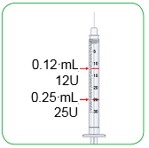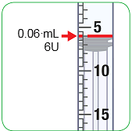

- To help with injecting Myalepta solution using the small 0.3 mL syringe, the last column in the table below shows the ‘Unit’ measurement on the syringe that relates to the different potential doses of the medicine prescribed by your doctor, nurse, or pharmacist.

Converting dose from ‘mL’ to ‘Units’ when using the 0.3 mL syringe
Weight of child | Dose of Myalepta | Amount of mixed Myalepta solution | Amount of mixed Myalepta solution to inject in ‘Unit’ measurements on your 0.3 mL syringe
9 kg | 0.54 mg | 0.10 mL | 10
10 kg | 0.60 mg | 0.12 mL | 12
11 kg | 0.66 mg | 0.13 mL | 13
12 kg | 0.72 mg | 0.14 mL | 14
13 kg | 0.78 mg | 0.15 mL | 15
14 kg | 0.84 mg | 0.16 mL | 16
15 kg | 0.90 mg | 0.18 mL | 18
16 kg | 0.96 mg | 0.19 mL | 19
17 kg | 1.02 mg | 0.20 mL | 20
18 kg | 1.08 mg | 0.21 mL | 21
19 kg | 1.14 mg | 0.22 mL | 22
20 kg | 1.20 mg | 0.24 mL | 24
21 kg | 1.26 mg | 0.25 mL | 25
22 kg | 1.32 mg | 0.26 mL | 26
23 kg | 1.38 mg | 0.27 mL | 27
24 kg | 1.44 mg | 0.28 mL | 28
25 kg | 1.50 mg | 0.30 mL | 30

Using the 1 mL syringe
- This syringe shows the injection amount in mL, so you should inject the amount your doctor, nurse, or pharmacist has told you to. You do not need to convert the amount from mL to Units.
- You will be given the 1 mL syringe to use if your daily dose is more than 1.5 mg up to 5 mg, which as a volume is greater than 0.3 mL up to 1.0 mL of Myalepta solution.
- Each 0.1 mL is shown as a number with a big line.
- Each 0.05 mL is shown as a medium size line.
- Each 0.01 mL is shown as a smaller line.
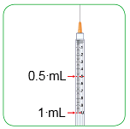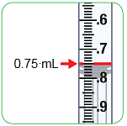

Using the 2.5 mL syringe
- This syringe shows the injection amount in mL, so you should inject the amount your doctor, nurse, or pharmacist has told you to. You do not need to convert the amount from mL to Units.
- You will be given the 2.5 mL syringe to use if your daily dose is more than 5 mg up to 10 mg, which as a volume is greater than 1.0 mL of Myalepta solution.
- Each 0.5 mL is shown as a number next to a big line.
- Each 0.1 mL is shown as a smaller line between the big lines.

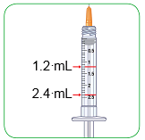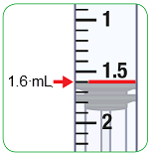

Step A: Setting up

1) Get together all the materials you will need for your injection. These will have been given to you by your doctor, nurse, or pharmacist.

On a clean, well-lit work surface, place the following items:
- a glass vial of Myalepta powder
- a container of water for injections for dissolving the Myalepta powder
  - The water for injections might come in glass or plastic ampoules, or glass vials with a rubber stopper.
- alcohol wipes (to clean your skin where you will inject and to clean the tops of the vials)
- sharps disposal container (to safely dispose of the injection equipment afterwards)

You will also need 2 syringes:
- One 1 mL syringe with a 21 gauge, 40 mm needle for dissolving the powder
- One injection syringe with a much shorter needle for injecting the solution under your skin
The size of this syringe will be chosen by your doctor, nurse or pharmacist for your dose of Myalepta.
  - If your dose is 1.5 mg or less, you will use a 0.3 mL syringe.
  - If your dose is more than 1.5 mg up to 5 mg, you will use a 1 mL syringe.
  - If your dose is more than 5 mg, you will use a 2.5 mL syringe.
  - If your dose is more than 5 mg, your doctor, nurse or pharmacist might tell you to give the dose as two separate injections. See section 3 “How much to inject” for more information.

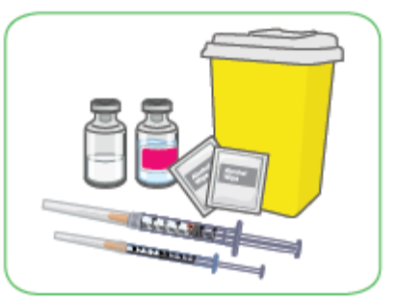

2) Before preparing Myalepta solution, allow the powder vial to reach room temperature for about 10 minutes.

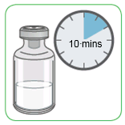

3) Wash your hands before preparing the medicine.

Step B: Filling the 1 mL syringe with 0.6 mL of water for injections

4) Take the 1 mL syringe out of the plastic wrapper. Always use a new syringe.
- The 1 mL syringe and needle will be provided separately.
- How you connect the needle to the syringe will be depend on if you have been provided your water for injection in a plastic ampoule, a glass ampoule, or a glass vial (see below for specific instructions).

5) Withdraw 0.6 mL of water for injection into the 1 mL syringe.

Your doctor, nurse or pharmacist will give you ‘water for injection’ with the medicine vial and syringes. This is mixed with the Myalepta powder to dissolve the powder to make the liquid medicine that you inject. The water for injection will come in either:
- a plastic ampoule
- a glass ampoule
- a glass vial (with rubber stopper)
Always use a new ampoule or vial of water for injection. Never use remaining water for injection left over from a previous day’s preparation of Myalepta solution.

Plastic ampoule of water for injection

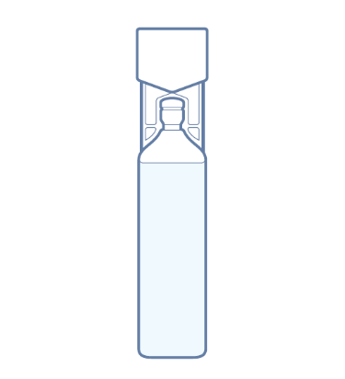

The plastic ampoule is a sealed container with a twist-off top.

To remove the water for injection, break open the ampoule.
- Hold the ampoule so that the top is facing up.
- Hold the bottom of the ampoule in one hand and the top of the ampoule in your other hand.
- Keeping the bottom of the ampoule still, gently twist the top of the ampoule until it is removed.

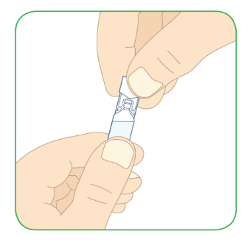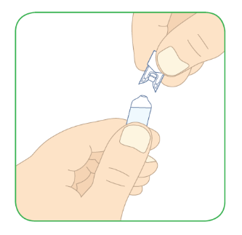

- Do not attach the needle to the syringe.
- Without the needle attached, insert the 1 mL syringe tip into the top of the plastic ampoule as far as possible.

With the syringe still in the ampoule, turn the ampoule and syringe upside down. The syringe will now be facing up.

With the syringe still in the ampoule, pull the plunger down carefully,
- Pull down until the top rim of the plunger lines up with the black 0.6 mL line.
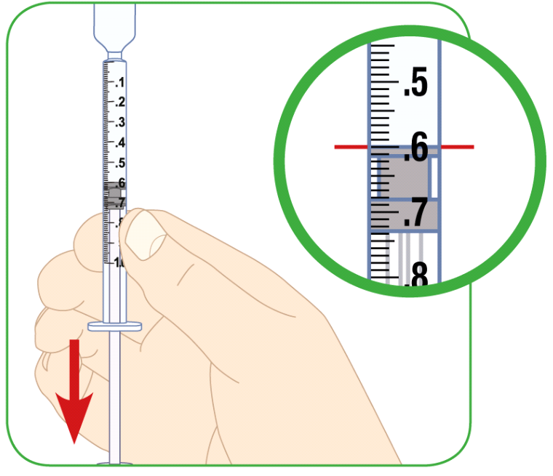
- You must check for air pockets or air bubbles in your 1 mL syringe. See steps 6-8 below on removal of air pockets and air bubbles from the syringe.
- Remove the syringe from the plastic ampoule.

Attach the needle to the syringe.
- Do not over-tighten the needle.
- Do not remove the needle guard.
- Do not touch the needle.

Glass ampoule of water for injection

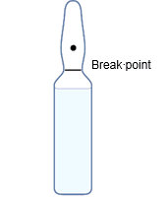

The glass ampoule is a sealed container.

Before opening the water for injection ampoule, prepare the 1 mL syringe by attaching the needle to it. Do not over-tighten the needle.
- Remove the needle guard.
- Do not touch the needle.

To remove the water for injection, break open the ampoule at the break-point as shown in the picture above.
- Hold the ampoule so that the tip is facing up.
- Use the alcohol swab to clean the break point on the ampoule.
- Hold the bottom of the ampoule in one hand and the top of the ampoule in your other hand.
- Keeping the bottom of the ampoule still, snap the tip off.
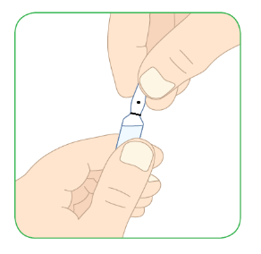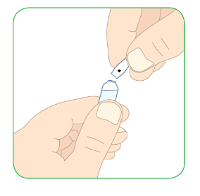

Insert the 1 mL syringe into the glass ampoule.
- The glass ampoule should be at a 45 degree angle to the ground.
- The needle should go as far into the ampoule as possible.

With the needle still in the ampoule, pull the plunger up carefully.
- Pull up until the top rim of the plunger lines up with the black 0.6 mL line.
- You must check for air pockets or air bubbles in your 1 mL syringe. See steps 6-8 below on removal of air pockets and air bubbles from the syringe.
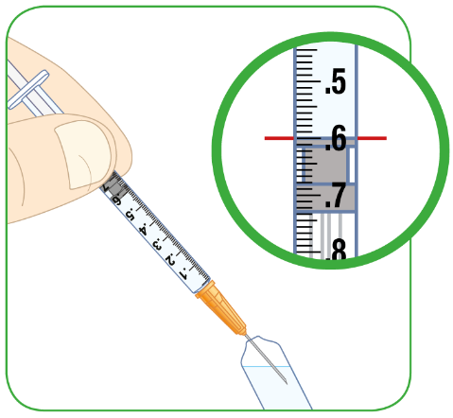

Glass vial of water for injection

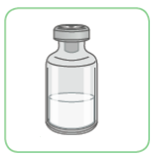

The glass vial will have a plastic cap that you should remove, revealing a rubber seal below.
- Do not remove the rubber seal.

Attach the needle to the 1 mL syringe. Do not over-tighten the needle.
- Remove the needle cover.
- Do not touch the needle.
- Pull the plunger down to the 0.6 mL line to draw air into the syringe.

Place the vial on a hard, flat surface.
- Insert the 1 mL syringe needle into the vial, through the rubber seal.
- The needle should be facing down.
- The needle should go all the way into the vial.

Push the plunger all the way down.
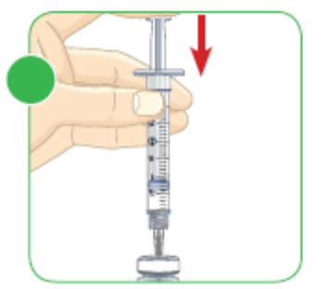

With the needle still in the vial, turn the vial and syringe upside down. The needle will now be facing up.
- Do not remove the needle from the vial.
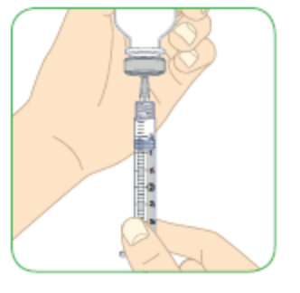

Pull the plunger down carefully
- Pull it down until the top rim of the plunger lines up with the black 0.6 mL line.
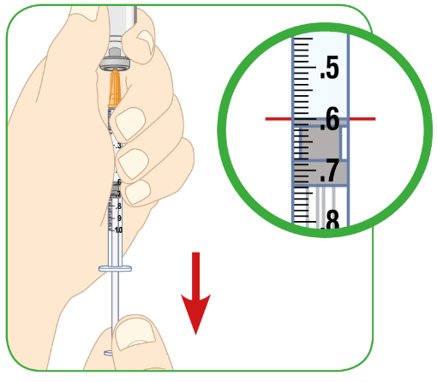

6) No matter whether you have withdrawn water for injection from a vial or ampoule, you must check for air pockets or air bubbles in your 1 mL syringe.
- Sometimes, large spaces of air (air pockets) get caught inside the syringe. You might also see smaller air bubbles in the syringe.
- You must remove an air pocket and air bubbles from the syringe to make sure you get the correct amount of sterile water in the syringe.

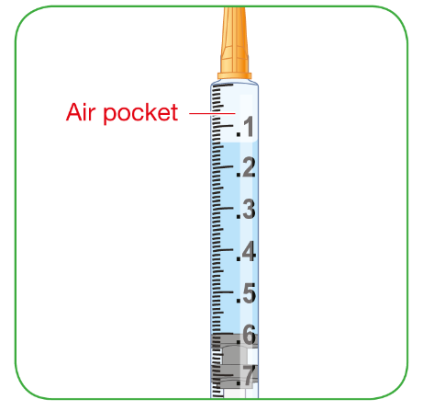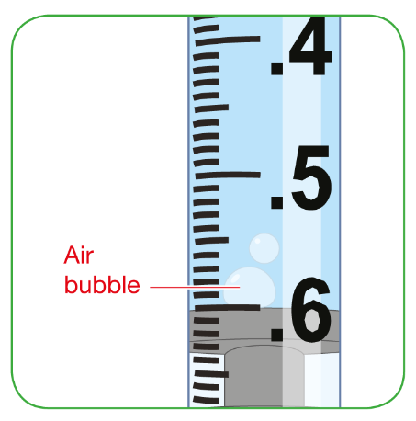

7) Remove any air pocket or air bubbles.

Using the glass vial or plastic ampoule
- With the syringe still inserted into the glass vial or plastic ampoule, tap the side of the syringe to move the air pocket/air bubbles to the top of the syringe.
- Carefully push the plunger back up to force the air out of the syringe.

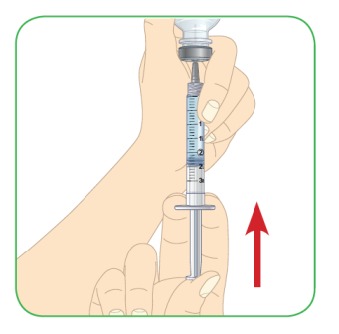

Using the glass ampoule
- Remove the syringe from the ampoule and hold it so that the needle faces up.
- Tap the side of the syringe to move the air pocket/air bubbles to the top of the syringe.
- Carefully push the plunger back up to force the air out of the syringe.

8) Check the amount of water for injection
- If there is less than 0.6 mL of water for injection in the syringe, draw more water for injection into the syringe and repeat the steps 6 and 7 until you have 0.6 mL in the syringe.

9) With 0.6 mL of water for injection in the syringe, remove the syringe from the vial or ampoule.
- Do not move the plunger.
- Do not touch the exposed needle on your syringe as it is sterile, and you may damage the needle or injure yourself.

Step C: Dissolving Myalepta

10) Make sure the vial of Myalepta powder has been out of the refrigerator for at least 10 minutes to reach room temperature.

11) Remove the plastic cap from the vial of Myalepta powder.
- Place the vial on a flat, hard surface.
- Clean the top of the vial with the alcohol wipe.

12) Insert the needle of the 1 mL syringe containing the 0.6 mL of water for injection all the way into the Myalepta vial containing the powder.

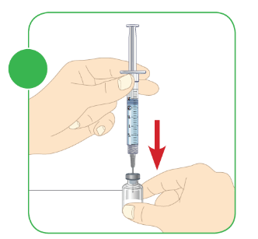

13) Hold the vial at 45 degree angle to the table and slowly push the plunger all the way down with your thumb.
- The water for injection should go down the inside wall of the vial.
- All of the water for injection should be injected into the vial.

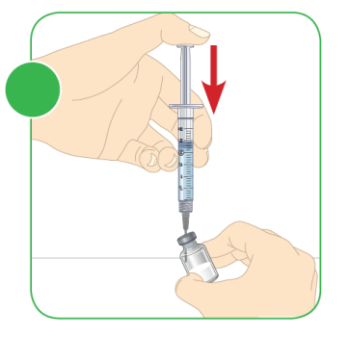

14) Take the needle out of the vial and throw away the syringe into a sharps disposal container.

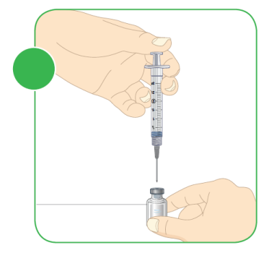

15) Mix the powder and water for injection
- Move the vial gently in a circle (swirling motion)
- Until the powder dissolves and the liquid is clear. Do not shake or vigorously mix.
- The solution will take less than 5 minutes to become clear.
When properly mixed, the Myalepta solution should be clear and free of lumps of dry powder, bubbles or foam. Do not use the solution if it is not clear or has bits or lumps in it. Throw it away and start again from step 1.

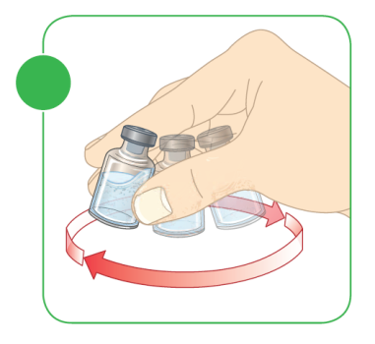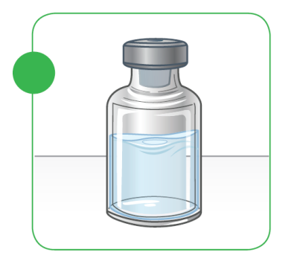

Step D: Filling the syringe with Myalepta for injection

16) To inject the Myalepta solution, you will use a new injection syringe, which will either be the 0.3 mL, 1.0 mL, or 2.5 mL syringe that was provided to you by your doctor, nurse or pharmacist. Remove the needle cover.
- Do not touch the needle.
- Do not move the plunger.

17) Insert the needle through the centre of the rubber bung, all the way into the vial containing the dissolved Myalepta solution.

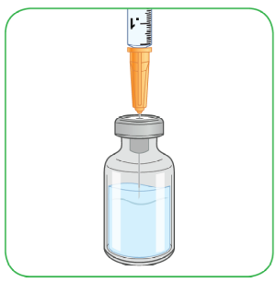

18) With the needle in the vial, turn the vial and syringe upside down.

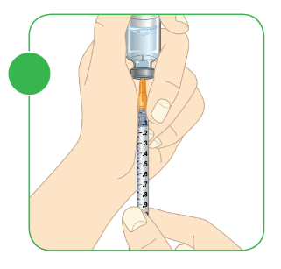

19) Keeping the needle inside the vial, pull the plunger down.
- The top rim of the plunger should line up with the black line on the syringe that matches the amount of Myalepta solution you are going to inject.

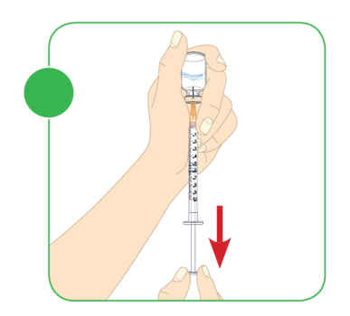

20) Check for air pockets and air bubbles.
- If you see an air pocket or any air bubbles, follow the same instructions described in step 7 to remove the air from the syringe.

21) If the syringe contains your correct dose amount of Myalepta solution, remove the needle from the vial.
- Do not move the plunger.
- Do not touch the needle.

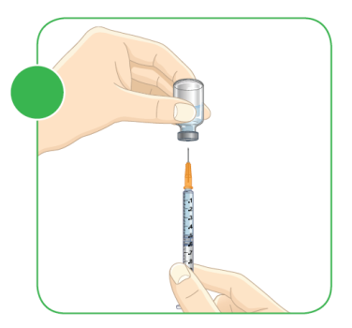
Step E: Choose and preparing where to inject

22) Carefully choose where you want to inject Myalepta. You can inject this medicine into the following areas:
- stomach area (abdomen), except for a 5 cm area directly around the belly button
- thigh
- back of the upper arm
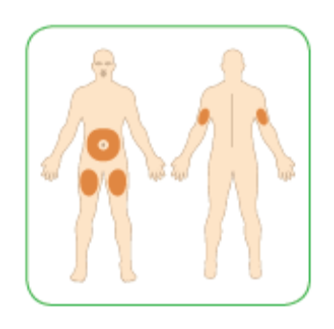

If you want to use the same area of the body for each injection, do not use the same spot that you used for your last injection.
- If you inject other medicines, do not inject Myalepta in the same site as you have done for those other medicines.

23) Clean the area where you will inject yourself with a clean alcohol swab and let the skin dry.
- Do not touch the area you have cleaned until you are injecting Myalepta.

Step F: Injecting Myalepta

Important: Myalepta must be injected under the skin (‘subcutaneous’). Do not inject into a muscle.

24) To inject under the skin, pinch the skin with one hand where you are going to inject.

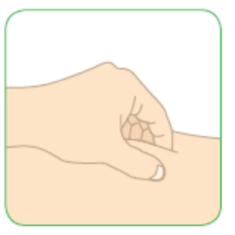

25) With the other hand, hold the syringe like a pencil.

26) Gently insert the needle into the skin at approximately a 45 degree angle to the body.
- Do not insert the needle into a muscle.
- The needle is short in length, and all of the needle should go into the skin at a 45 degree angle.

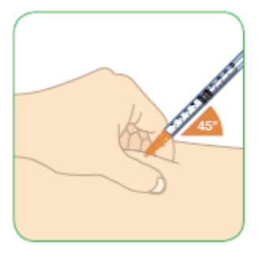

27) Gently use your thumb to push the plunger all the way down.
- Inject all of the medicine.
- If there is medicine left in the syringe, you have not had your full dose.

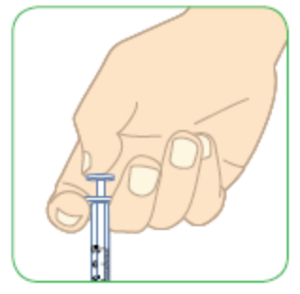

28) Remove the syringe from the skin.

Step G: Throwing away used materials

29) Throw away the two used syringes and all caps, vials, or ampoules in the sharps disposal container straight away.
- Talk to your doctor, nurse or pharmacist about correct disposal of your sharps disposal container once it becomes full. There might be local regulations for this.

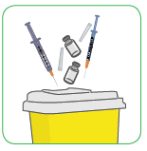

Important
- Do not use the syringes more than once. Use new syringes each time.
- The vials may remain almost completely filled with product after withdrawal of the required dose. Remaining solution should be discarded after use.
- Do not dissolve another dose of Myalepta powder with any ampoule or vial containing unused remaining water for injection. This unused water for injection should be disposed of in your sharps container. Always use a new ampoule or vial of water for injection each time when preparing to dissolve Myalepta powder.
- Do not recycle the syringes, caps, or sharps disposal container, or throw them into household waste.
- Always keep the sharps disposal container out of reach of children.

Package leaflet: Information for the patient

Myalepta 5.8 mg powder for solution for injection
metreleptin

This medicine is subject to additional monitoring. This will allow quick identification of new safety information. You can help by reporting any side effects you may get. See the end of section 4 for how to report side effects.

Read all of this leaflet carefully before you start using this medicine because it contains important information for you.
- Keep this leaflet. You may need to read it again.
- If you have any further questions, ask your doctor, pharmacist or nurse.
- This medicine has been prescribed for you only. Do not pass it on to others. It may harm them, even if their signs of illness are the same as yours.
- If you get any side effects, talk to your doctor, pharmacist or nurse. This includes any possible side effects not listed in this leaflet. See section 4.

What is in this leaflet

1. What Myalepta is and what it is used for
2. What you need to know before you use Myalepta
3. How to use Myalepta
4. Possible side effects
5. How to store Myalepta
6. Contents of the pack and other information
7. Instructions for use

1. What Myalepta is and what it is used for

Myalepta contains the active substance metreleptin.
- Metreleptin is similar to a human hormone called leptin.

What Myalepta is used for
Myalepta is used to treat the complications of not having enough leptin in patients with lipodystrophy.
It is used in adults, adolescents and children 2 years or over:
- who have generalised lipodystrophy (the whole of your body does not have enough fatty tissue)
It is used, when other treatments have been ineffective, in adults, and adolescents 12 years or over:
- who have partial lipodystrophy which is inherited (also called congenital or familial lipodystrophy)
- or partial lipodystrophy has been caused by your body’s response to something such as a viral illness (also called acquired lipodystrophy)

How Myalepta works
Natural leptin is produced by fatty tissue and has many functions in the body including:
- controlling how hungry you feel and your energy levels
- helping the insulin in your body manage sugar levels.
Metreleptin works by copying the effects of leptin. This improves the ability of the body to control energy levels.

2. What you need to know before you use Myalepta

Do not use Myalepta if:
- you are allergic to metreleptin or any of the other ingredients of this medicine (listed in section 6).

Warnings and precautions
Talk to your doctor, pharmacist or nurse before using Myalepta if:
- you are pregnant
- you have ever had a type of cancer called lymphoma
- you have ever had problems with your blood (such as a low blood count)
- you have ever had inflammation of an organ called the pancreas (‘pancreatitis’)
- you have or ever have had problems with your immune system (autoimmune disease including autoimmune-related liver problems)

Lymphoma
People with lipodystrophy can get a type of blood cancer called lymphoma, whether or not they are using Myalepta.
However, you may be at higher risk of getting a lymphoma when using the medicinal product.
- Your doctor will decide if you should use Myalepta and will monitor you during treatment.

Serious and severe infections
While being treated with Myalepta, your body might produce antibodies which may increase the risk of developing serious or severe infections. Tell your doctor straight-away if you develop a high temperature, accompanied by increasing tiredness (see section 4).

Low blood sugar with insulin or other anti-diabetic medicines
If you are using a medicine such as insulin or other medicines to treat diabetes, your doctor will closely monitor your blood sugar. Your doctor will change your dose of insulin or other medicines if needed.
This is to prevent your blood sugar from getting too low (‘hypo-glycaemia’). For signs of low blood sugar levels, see section 4 under ‘Signs of high and low blood sugar'.

High blood sugar and fat levels
You may have higher amounts of sugar (‘hyper-glycaemia’) or fat (‘hyper-triglyceridaemia’) in your blood while on Myalepta, which may be a sign that this medicine is not working as well as it should. Signs of high blood sugar levels and high fat levels are listed in section 4 under “Signs of high and low blood sugar” and “Signs of high fat”.
If you notice any of the symptoms referred to above and described further in section 4 of this leaflet, or you are not sure, talk to your doctor straight away. Your doctor might need to change your treatment.

Autoimmune Disease
People who have or have had problems with their immune system (autoimmune disease including autoimmune-related liver problems) may have worsening of their symptoms with Myalepta. Talk to your healthcare provider about what symptoms you should watch for that would warrant further testing.

Allergic reactions
While being treated with Myalepta, you may get an allergic reaction. Tell your doctor straight-away if you have any symptoms of an allergic reaction. Signs of an allergic reaction can be seen in section 4 under “Allergic reactions”.

Fertility
Myalepta might increase fertility in women with lipodystrophy (see section “Pregnancy, breast-feeding and fertility”).

How to stop using Myalepta
If you need to stop using Myalepta, your doctor will gradually reduce the dose over two weeks before stopping it altogether. Your doctor will also ask you to follow a reduced fat diet.
- It is important to gradually reduce the dose over two weeks because this can help prevent a sudden increase in the levels of fat (called ‘triglycerides’) in your blood.
- A sudden increase in the amount of triglyceride in your blood can make your pancreas inflamed (‘pancreatitis’). Gradually reducing your dose, and following a reduced fat diet may help to prevent this.
You should not stop using Myalepta unless your doctor tells you to.

Children and adolescents
Do not give this medicine to children below the age of 2 years with generalised lipodystrophy, or below the age of 12 years with partial lipodystrophy. This is because it is not known how this medicine will affect children under these ages.

Other medicines and Myalepta
Tell your doctor if you are using, have recently used or might use any other medicines. Myalepta can affect the way some other medicines work. Also some other medicines can affect the way this medicine works.
In particular, tell your doctor if you are taking any of the following medicines:
- statins for reducing cholesterol (such as atorvastatin)
- blood pressure medicines called ‘calcium channel blockers’
- theophylline used in lung problems such as asthma
- blood-thinning medicines (such as warfarin or phenprocoumon)
- medicines for epilepsy or fits (such as phenytoin)
- medicines which suppress the immune system (such as cyclosporine)
- medicines for sleep or anxiety called ‘benzodiazepines’

If any of the above apply to you (or you are not sure), talk to your doctor before using Myalepta. Some medicines need to be monitored while you are using Myalepta since the dose of these medicines might need to be changed.

Pregnancy, breast-feeding and fertility
If you are pregnant or breast-feeding, think you may be pregnant or are planning to have a baby, ask your doctor for advice before using this medicine.

You should not use Myalepta if you are pregnant or might become pregnant. This is because it is not known how metreleptin will affect your unborn baby.
- Women who could get pregnant should use effective contraception, including non-hormonal methods such as condoms, while using Myalepta.

Talk to your doctor if you are breast-feeding. You and your doctor will decide whether or not to continue breast-feeding while using this medicine.
It is not known if metreleptin will pass into breast milk.
Myalepta might increase fertility in women with lipodystrophy.

Driving and using machines
Myalepta has minor influence on the ability to drive and use machines. You might feel dizzy or tired when using this medicine. If this happens, do not drive or use any tools or machines. Talk to your doctor if you are not sure.

3. How to use Myalepta

Always use this medicine exactly as your doctor has told you. Check with your doctor if you are not sure.

Myalepta is an injection once a day under the skin (‘subcutaneous injection’). This medicine is for use in children aged 2 years and above, adolescents and adults with generalised lipodystrophy; it is also for use in children aged 12 years and above, adolescents and adults with partial lipodystrophy.
While using this medicine, you or your child will be monitored by your doctor, who will decide the dose you or your child should use.

Your doctor may decide that you inject yourself. Your doctor, nurse or pharmacist will show you how to prepare and inject this medicine.
- Do not try to prepare the medicine or inject yourself if you have not been trained.

How much to inject
Your dose of Myalepta may change over time depending on how this medicine works for you. The Myalepta powder is dissolved by mixing it with water for injections to make the solution for injecting. Read the “Instructions for Use” (see section 7) for how to make the solution before injecting.
Your doctor will have prescribed the correct dose for you, based on the following:
- If you weigh 40 kg or less:
  - A starting dose is 0.06 mg (0.012 mL of solution) for each kilogram of body weight.
- If you are male and weigh more than 40 kg:
  - A starting dose is 2.5 mg (0.5 mL of solution).
- If you are female and weigh more than 40 kg:
  - A starting dose is 5 mg (1 mL of solution).
Your doctor or pharmacist will tell you how much of the solution to inject. If you are not sure how much of the solution to inject, talk to your doctor or pharmacist before injecting.
- The syringe you need to use to inject this medicine depends on the dose prescribed for you.
  - Your pharmacist will give you the correct syringe for injecting.
  - See the “Instructions for Use” to find out which syringe to use.
- To know how much medicine to inject (in mL), you divide your dose (in mg) by 5.
  - For example, if you have been prescribed a 5 mg dose of Myalepta, 5 mg divided by 5 gives you 1 mL which is the amount you need to inject of the solution, using a 1 mL syringe.
- If your dose is 1.50 mg (0.30 mL of solution) or less, you will need to use a 0.3 mL syringe.
  - The 0.3 mL syringe will show the injection amount in ‘Unit’ instead of ‘mL’. See the “Instructions for Use” (section 7) for more information on reading and using the different syringes.
  - To know how much solution to inject (in Units), divide your dose (in mg) by 5, and then times it by 100.
If you need to inject 1 mL or more of Myalepta solution, your doctor might tell you to give the dose as two separate injections. This can help make the injections more comfortable.
You must use a clean syringe and needle for both injections.
If you are not sure how much of the solution to inject, talk to your doctor or pharmacist before injecting.
When small doses/volumes are prescribed (e.g. in children), the vials will remain almost completely filled with product after withdrawal of the required dose. Remaining solution should be discarded after use.

If you use more Myalepta than you should

If you use more Myalepta than you should, talk to your doctor or go to a hospital straight away. Your doctor will monitor you for side effects.

If you forget to use Myalepta
- If you forget to inject a dose, inject it as soon as you remember.
- Then have your normal dose the next day.
- Do not use a double dose to make up for a forgotten dose.

If you have injected less Myalepta than you should, talk to your doctor straight away. Your doctor will monitor you for side effects.

If you stop using Myalepta
Do not stop using Myalepta without talking to your doctor. Your doctor will decide if you should stop using this medicine.

If you need to stop using Myalepta, your doctor will gradually reduce the dose over two weeks. See section 2 “How to stop using Myalepta” for more information.

If you have any further questions on the use of this medicine, ask your doctor.

4. Possible side effects

Like all medicines, this medicine can cause side effects, although not everybody gets them.
Possible side effects with this medicine:

Serious side effects
Tell your doctor straight away if you notice any of the following serious side effects – you may need urgent medical treatment. If you cannot contact your doctor, you should seek emergency medical help:
- low blood sugar (glucose)
- increased blood sugar (glucose)
- blood clot in your veins (deep vein thrombosis) - pain, swelling, warmth & redness, usually occurring in lower leg or thigh
- fluid in your lungs - difficulty breathing or cough
- feeling sleepy or confused

Allergic reactions
Talk to a doctor straight away if you notice any allergic reactions, including:
- breathing problems
- swelling and reddening of the skin, hives
- swelling of your face, lips, tongue or throat
- stomach pain, feeling sick (nausea) and being sick (vomiting)
- fainting or feeling dizzy
- severe pain in your stomach (abdomen)
- very fast heartbeat

Inflamed pancreas (‘pancreatitis’):
Talk to a doctor straight away if you notice any signs of an inflamed pancreas, including:
- sudden severe pain in your stomach (abdomen)
- feeling sick (nausea) or being sick (vomiting)
- diarrhoea

Other side effects
Tell your doctor if you notice any of the following side effects.

Very common (may affect more than 1 in 10 people):
- weight loss

Common (may affect up to 1 in 10 people):
- loss of interest in food
- headache
- hair loss
- unusually heavy or long menstrual bleeding
- feeling tired
- bruising, reddening, itching or hives where the injection is given
- your body producing antibodies to metreleptin which may increase the risk of developing serious or severe infections. You may notice you develop a high temperature, accompanied by increasing tiredness

Not known (frequency cannot be estimated from the available data):
- flu
- chest infection
- diabetes
- a higher than normal desire for food or excessive eating
- a faster than normal heart rate
- cough
- breathlessness
- muscle pain (‘myalgia’)
- joint pain
- swelling in your hands and feet
- increase in fatty tissue
- swelling or bleeding under the skin, where you injected
- a feeling of general discomfort, uneasiness or pain (‘malaise’)
- increased fat in the blood (‘triglycerides’)
- an increase in ‘HbA1c’ in your blood, shown in tests
- weight gain
- swelling or bleeding under the skin (‘haemorrhage’)
- high blood sugar levels
- having a high temperature
- chills
- shaking.
Tell your doctor if you notice any of the above side effects.

Signs of high and low blood sugar
Symptoms of low blood sugar levels include:
- feeling dizzy
- feeling more sleepy or confused
- being clumsy and dropping things
- feeling more hungry than normal
- sweating more than normal
- feeling more irritable or more nervous
If you notice any of the symptoms above, or you are not sure, talk to your doctor straight away. Your doctor might need to change your treatment.
Symptoms of high blood sugar levels include:
- feeling very thirsty or hungry
- going to the toilet to pass urine more often
- feeling more sleepy
- feeling sick or being sick
- blurred vision
- pain in the chest or back
- feeling out of breath

Signs of high fat
Symptoms of high fat levels include:
- pain in the chest
- pain below the ribs like heartburn or indigestion
- feeling sick or being sick

Tell your doctor if you notice any of the above side effects.

Reporting of side effects
If you get any side effects, talk to your doctor, pharmacist or nurse. This includes any possible side effects not listed in this leaflet. You can also report side effects directly via the national reporting system listed in Appendix V. By reporting side effects, you can help provide more information on the safety of this medicine.

5. How to store Myalepta

Keep this medicine out of the sight and reach of children.

Do not use this medicine after the expiry date which is stated on the vial and carton. The expiry date refers to the last day of that month.

Store in a refrigerator (2 °C-8 °C). Keep the vial in the outer carton in order to protect from light.
After reconstitution, the solution must be administered immediately and cannot be stored for later use. Dispose of any unused medicine.

Do not use this medicine if the solution is not clear, is coloured or has bits or lumps in it.

Do not throw away any medicines via wastewater or household waste. Ask your pharmacist how to throw away medicines you no longer use. These measures will help protect the environment.

6. Contents of the pack and other information

What Myalepta contains
- The active substance is metreleptin.
- Each vial contains 5.8 milligrams of metreleptin. After dissolving the vial contents in 1.1 millilitres of water for injections, each millilitre contains 5 milligrams of metreleptin.
- The other ingredients are: glycine, sucrose, polysorbate 20, glutamic acid, sodium hydroxide (for pH adjustment).

What Myalepta looks like and contents of the pack

Myalepta is presented as a powder for solution for injection (powder for injection). It is a white powder supplied in a glass vial with a rubber stopper and an aluminium seal with a blue plastic flip-off cap.

Myalepta is available in packs containing 1 or 30 vials.

Not all pack sizes may be marketed in your country.

Your doctor, nurse or pharmacist should provide you separately with the appropriate syringes and needles, wipes and water for injections to enable you to prepare and inject Myalepta. They will provide a ‘sharps disposal container’ for you to put your used vials, syringes and needles in.

Marketing Authorisation Holder
Amryt Pharmaceuticals DAC
45 Mespil Road
Dublin 4
Ireland
medinfo@amrytpharma.com

Manufacturer
Eurofins PHAST GmbH
Kardinal-Wendel-Straße 16
66424 Homburg
Germany

This leaflet was last revised in (month YYYY).

This medicine has been authorised under ‘exceptional circumstances’. This means that because of the rarity of this disease it has been impossible to get complete information on this medicine.
The European Medicines Agency will review any new information on this medicine every year and this leaflet will be updated as necessary.

Other sources of information

Detailed information on this medicine is available on the European Medicines Agency web site: http://www.ema.europa.eu.

There are also links to other websites about rare diseases and treatments.

7. Instructions for Use

Before using Myalepta, you must first read Sections 1 – 6 of this package leaflet, and then read Section 7 Instructions for Use.

Before you begin self-administering this medicine at home, your doctor, nurse or pharmacist will train you how to prepare and inject Myalepta. Contact them if you are unclear about anything or if you need more information or help. Take your time to carefully prepare and inject your medicine, which when including the period of the vial warming up after being taken out of the fridge, can be approximately 20 minutes in total.

Additional training information
There are additional education training information and videos to help you understand how to use Myalepta correctly. Details on how to access these are available from your doctor.

Reading the syringe

Line up the top rim of the plunger with the line for the prescribed dose. An example is given below for the different syringe sizes. If your syringe looks different or has different dose markings, talk to your doctor, nurse or pharmacist for more information.

Using the 0.3 mL syringe
- The 0.3 mL syringe shows the injection amount in ‘U’ instead of ‘mL’.
- ‘U’ means ‘Units’.
- 1 U is the same as 0.01 mL.
- Each 5 U is shown as a number with a big line. This is the same as 0.05 mL.
- Each 1 U is shown as a smaller line between the big lines. This is the same as 0.01 mL.
- Each 0.5 U is shown as a small line between two 1 U lines. This is the same as 0.005 mL.

- To help with injecting Myalepta solution using the small 0.3 mL syringe, the last column in the table below shows the ‘Unit’ measurement on the syringe that relates to the different potential doses of the medicine prescribed by your doctor, nurse, or pharmacist.

Converting dose from ‘mL’ to ‘Units’ when using the 0.3 mL syringe
Weight of child | Dose of Myalepta | Amount of mixed Myalepta solution | Amount of mixed Myalepta solution to inject in ‘Unit’ measurements on your 0.3 mL syringe
9 kg | 0.54 mg | 0.10 mL | 10
10 kg | 0.60 mg | 0.12 mL | 12
11 kg | 0.66 mg | 0.13 mL | 13
12 kg | 0.72 mg | 0.14 mL | 14
13 kg | 0.78 mg | 0.15 mL | 15
14 kg | 0.84 mg | 0.16 mL | 16
15 kg | 0.90 mg | 0.18 mL | 18
16 kg | 0.96 mg | 0.19 mL | 19
17 kg | 1.02 mg | 0.20 mL | 20
18 kg | 1.08 mg | 0.21 mL | 21
19 kg | 1.14 mg | 0.22 mL | 22
20 kg | 1.20 mg | 0.24 mL | 24
21 kg | 1.26 mg | 0.25 mL | 25
22 kg | 1.32 mg | 0.26 mL | 26
23 kg | 1.38 mg | 0.27 mL | 27
24 kg | 1.44 mg | 0.28 mL | 28
25 kg | 1.50 mg | 0.30 mL | 30

Using the 1 mL syringe
- This syringe shows the injection amount in mL, so you should inject the amount your doctor, nurse, or pharmacist has told you to. You do not need to convert the amount from mL to Units.
- You will be given the 1 mL syringe to use if your daily dose is more than 1.5 mg up to 5 mg, which as a volume is greater than 0.3 mL up to 1.0 mL of Myalepta solution.
- Each 0.1 mL is shown as a number with a big line.
- Each 0.05 mL is shown as a medium size line.
- Each 0.01 mL is shown as a smaller line.

Using the 2.5 mL syringe
- This syringe shows the injection amount in mL, so you should inject the amount your doctor, nurse, or pharmacist has told you to. You do not need to convert the amount from mL to Units.
- You will be given the 2.5 mL syringe to use if your daily dose is more than 5 mg up to 10 mg, which as a volume is greater than 1.0 mL of Myalepta solution.
- Each 0.5 mL is shown as a number next to a big line.
- Each 0.1 mL is shown as a smaller line between the big lines.

Step A: Setting up

1) Get together all the materials you will need for your injection. These will have been given to you by your doctor, nurse, or pharmacist.

On a clean, well-lit work surface, place the following items:
- a glass vial of Myalepta powder
- a container of water for injections for dissolving the Myalepta powder
  - The water for injections might come in glass or plastic ampoules, or glass vials with a rubber stopper.
- alcohol wipes (to clean your skin where you will inject and to clean the tops of the vials)
- sharps disposal container (to safely dispose of the injection equipment afterwards)

You will also need 2 syringes:
- One 3 mL syringe with a 21 gauge, 40 mm needle for dissolving the powder
- One injection syringe with a much shorter needle for injecting the solution under your skin
The size of this syringe will be chosen by your doctor, nurse or pharmacist for your dose of Myalepta.
  - If your dose is 1.5 mg or less, you will use a 0.3 mL syringe.
  - If your dose is more than 1.5 mg up to 5 mg, you will use a 1 mL syringe.
  - If your dose is more than 5 mg, you will use a 2.5 mL syringe.
  - If your dose is more than 5 mg, your doctor, nurse or pharmacist might tell you to give the dose as two separate injections. See section 3 “How much to inject” for more information.

2) Before preparing Myalepta solution, allow the powder vial to reach room temperature for about 10 minutes.

3) Wash your hands before preparing the medicine.

Step B: Filling the 3 mL syringe with 1.1 mL of water for injections

4) Take the 3 mL syringe out of the plastic wrapper. Always use a new syringe.
- The 3 mL syringe and needle will be provided separately.
- How you connect the needle to the syringe will be depend on if you have been provided your water for injection in a plastic ampoule, a glass ampoule, or a glass vial (see below for specific instructions).

5) Withdraw 1.1 mL of water for injection into the 3 mL syringe.

Your doctor, nurse or pharmacist will give you ‘water for injection’ with the medicine vial and syringes. This is mixed with the Myalepta powder to dissolve the powder to make the liquid medicine that you inject. The water for injection will come in either:
- a plastic ampoule
- a glass ampoule
- a glass vial (with rubber stopper)
Always use a new ampoule or vial of water for injection. Never use remaining water for injection left over from a previous day’s preparation of Myalepta solution.

Plastic ampoule of water for injection

The plastic ampoule is a sealed container with a twist-off top.

To remove the water for injection, break open the ampoule.
- Hold the ampoule so that the top is facing up.
- Hold the bottom of the ampoule in one hand and the top of the ampoule in your other hand.
- Keeping the bottom of the ampoule still, gently twist the top of the ampoule until it is removed.

- Do not attach the needle to the syringe.
- Without the needle attached, insert the 3 mL syringe tip into the top of the plastic ampoule as far as possible.

With the syringe still in the ampoule, turn the ampoule and syringe upside down. The syringe will now be facing up.

With the syringe still in the ampoule, pull the plunger down carefully,
- Pull down until the top rim of the plunger lines up with the black 1.1 mL line.
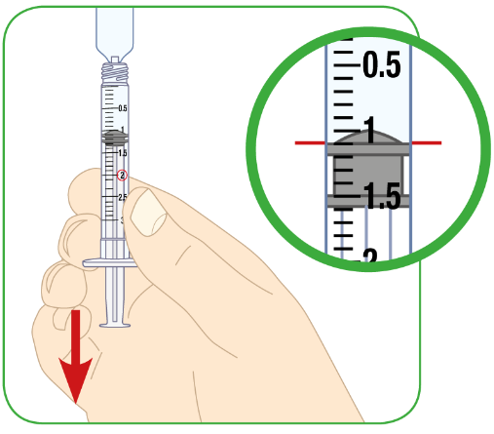
- You must check for air pockets or air bubbles in your 3 mL syringe. See steps 6-8 below on removal of air pockets and air bubbles from the syringe.
- Remove the syringe from the plastic ampoule.

Attach the needle to the syringe.
- Do not over-tighten the needle.
- Do not remove the needle guard.
- Do not touch the needle.

Glass ampoule of water for injection

The glass ampoule is a sealed container.

Before opening the water for injection ampoule, prepare the 3 mL syringe by attaching the needle to it. Do not over-tighten the needle.
- Remove the needle guard.
- Do not touch the needle.

To remove the water for injection, break open the ampoule at the break-point as shown in the picture above.
- Hold the ampoule so that the tip is facing up.
- Use the alcohol swab to clean the break point on the ampoule.
- Hold the bottom of the ampoule in one hand and the top of the ampoule in your other hand.
- Keeping the bottom of the ampoule still, snap the tip off.

Insert the 3 mL syringe into the glass ampoule.
- The glass ampoule should be at a 45 degree angle to the ground.
- The needle should go as far into the ampoule as possible.

With the needle still in the ampoule, pull the plunger up carefully.
- Pull up until the top rim of the plunger lines up with the black 1.1 mL line.
- You must check for air pockets or air bubbles in your 3 mL syringe. See steps 6-8 below on removal of air pockets and air bubbles from the syringe.
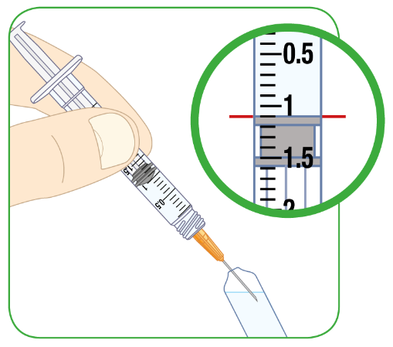

Glass vial of water for injection

The glass vial will have a plastic cap that you should remove, revealing a rubber seal below.
- Do not remove the rubber seal.

Attach the needle to the 3 mL syringe. Do not over-tighten the needle.
- Remove the needle cover.
- Do not touch the needle.
- Pull the plunger down to the 1.1 mL line to draw air into the syringe.

Place the vial on a hard, flat surface.
- Insert the 3 mL syringe needle into the vial, through the rubber seal.
- The needle should be facing down.
- The needle should go all the way into the vial.

Push the plunger all the way down.

With the needle still in the vial, turn the vial and syringe upside down. The needle will now be facing up.
- Do not remove the needle from the vial.

Pull the plunger down carefully
- Pull it down until the top rim of the plunger lines up with the black 1.1 mL line.
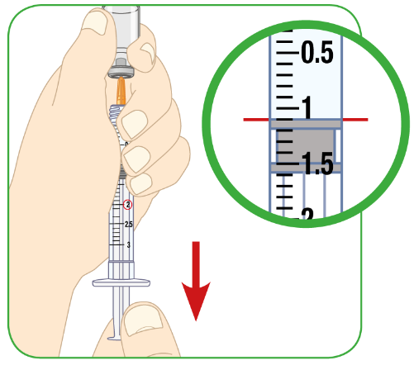

6) No matter whether you have withdrawn water for injection from a vial or ampoule, you must check for air pockets or air bubbles in your 3 mL syringe.
- Sometimes, large spaces of air (air pockets) get caught inside the syringe. You might also see smaller air bubbles in the syringe.
- You must remove an air pocket and air bubbles from the syringe to make sure you get the correct amount of sterile water in the syringe.

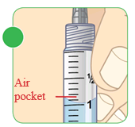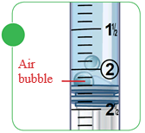

7) Remove any air pocket or air bubbles.

Using the glass vial or plastic ampoule
- With the syringe still inserted into the glass vial or plastic ampoule, tap the side of the syringe to move the air pocket/air bubbles to the top of the syringe.
- Carefully push the plunger back up to force the air out of the syringe.

Using the glass ampoule
- Remove the syringe from the ampoule and hold it so that the needle faces up.
- Tap the side of the syringe to move the air pocket/air bubbles to the top of the syringe.
- Carefully push the plunger back up to force the air out of the syringe.

8) Check the amount of water for injection
- If there is less than 1.1 mL of water for injection in the syringe, draw more water for injection into the syringe and repeat the steps 6 and 7 until you have 1.1 mL in the syringe.

9) With 1.1 mL of water for injection in the syringe, remove the syringe from the vial or ampoule.
- Do not move the plunger.
- Do not touch the exposed needle on your syringe as it is sterile, and you may damage the needle or injure yourself.

Step C: Dissolving Myalepta

10) Make sure the vial of Myalepta powder has been out of the refrigerator for at least 10 minutes to reach room temperature.

11) Remove the plastic cap from the vial of Myalepta powder.
- Place the vial on a flat, hard surface.
- Clean the top of the vial with the alcohol wipe.

12) Insert the needle of the 3 mL syringe containing the 1.1 mL of water for injection all the way into the Myalepta vial containing the powder.

13) Hold the vial at 45 degree angle to the table and slowly push the plunger all the way down with your thumb.
- The water for injection should go down the inside wall of the vial.
- All of the water for injection should be injected into the vial.

14) Take the needle out of the vial and throw away the syringe into a sharps disposal container.

15) Mix the powder and water for injection
- Move the vial gently in a circle (swirling motion)
- Until the powder dissolves and the liquid is clear. Do not shake or vigorously mix.
- The solution will take less than 5 minutes to become clear.
When properly mixed, the Myalepta solution should be clear and free of lumps of dry powder, bubbles or foam. Do not use the solution if it is not clear or has bits or lumps in it. Throw it away and start again from step 1.

Step D: Filling the syringe with Myalepta for injection

16) To inject the Myalepta solution, you will use a new injection syringe, which will either be the 0.3 mL, 1.0 mL, or 2.5 mL syringe that was provided to you by your doctor, nurse or pharmacist. Remove the needle cover.
- Do not touch the needle.
- Do not move the plunger.

17) Insert the needle through the centre of the rubber bung, all the way into the vial containing the dissolved Myalepta solution.

18) With the needle in the vial, turn the vial and syringe upside down.

19) Keeping the needle inside the vial, pull the plunger down.
- The top rim of the plunger should line up with the black line on the syringe that matches the amount of Myalepta solution you are going to inject.

20) Check for air pockets and air bubbles.
- If you see an air pocket or any air bubbles, follow the same instructions described in step 7 to remove the air from the syringe.

21) If the syringe contains your correct dose amount of Myalepta solution, remove the needle from the vial.
- Do not move the plunger.
- Do not touch the needle.

Step E: Choose and preparing where to inject

22) Carefully choose where you want to inject Myalepta. You can inject this medicine into the following areas:
- stomach area (abdomen), except for a 5 cm area directly around the belly button
- thigh
- back of the upper arm

If you want to use the same area of the body for each injection, do not use the same spot that you used for your last injection.
- If you inject other medicines, do not inject Myalepta in the same site as you have done for those other medicines.

23) Clean the area where you will inject yourself with a clean alcohol swab and let the skin dry.
- Do not touch the area you have cleaned until you are injecting Myalepta.

Step F: Injecting Myalepta

Important: Myalepta must be injected under the skin (‘subcutaneous’). Do not inject into a muscle.

24) To inject under the skin, pinch the skin with one hand where you are going to inject.

25) With the other hand, hold the syringe like a pencil.

26) Gently insert the needle into the skin at approximately a 45 degree angle to the body.
- Do not insert the needle into a muscle.
- The needle is short in length, and all of the needle should go into the skin at a 45 degree angle.

27) Gently use your thumb to push the plunger all the way down.
- Inject all of the medicine.
- If there is medicine left in the syringe, you have not had your full dose.

28) Remove the syringe from the skin.

Step G: Throwing away used materials

29) Throw away the two used syringes and all caps, vials, or ampoules in the sharps disposal container straight away.
- Talk to your doctor, nurse or pharmacist about correct disposal of your sharps disposal container once it becomes full. There might be local regulations for this.

Important
- Do not use the syringes more than once. Use new syringes each time.
- The vials may remain almost completely filled with product after withdrawal of the required dose. Remaining solution should be discarded after use.
- Do not dissolve another dose of Myalepta powder with any ampoule or vial containing unused remaining water for injection. This unused water for injection should be disposed of in your sharps container. Always use a new ampoule or vial of water for injection each time when preparing to dissolve Myalepta powder.
- Do not recycle the syringes, caps, or sharps disposal container, or throw them into household waste.
- Always keep the sharps disposal container out of reach of children.

Package leaflet: Information for the patient

Myalepta 11.3 mg powder for solution for injection
metreleptin

This medicine is subject to additional monitoring. This will allow quick identification of new safety information. You can help by reporting any side effects you may get. See the end of section 4 for how to report side effects.

Read all of this leaflet carefully before you start using this medicine because it contains important information for you.
- Keep this leaflet. You may need to read it again.
- If you have any further questions, ask your doctor, pharmacist or nurse.
- This medicine has been prescribed for you only. Do not pass it on to others. It may harm them, even if their signs of illness are the same as yours.
- If you get any side effects, talk to your doctor, pharmacist or nurse. This includes any possible side effects not listed in this leaflet. See section 4.

What is in this leaflet

1. What Myalepta is and what it is used for
2. What you need to know before you use Myalepta
3. How to use Myalepta
4. Possible side effects
5. How to store Myalepta
6. Contents of the pack and other information
7. Instructions for use

1. What Myalepta is and what it is used for

Myalepta contains the active substance metreleptin.
- Metreleptin is similar to a human hormone called leptin.

What Myalepta is used for
Myalepta is used to treat the complications of not having enough leptin in patients with lipodystrophy.
It is used in adults, adolescents and children 2 years or over:
- who have generalised lipodystrophy (the whole of your body does not have enough fatty tissue)
It is used, when other treatments have been ineffective, in adults, and adolescents 12 years or over:
- who have partial lipodystrophy which is inherited (also called congenital or familial lipodystrophy)
- or partial lipodystrophy has been caused by your body’s response to something such as a viral illness (also called acquired lipodystrophy)

How Myalepta works
Natural leptin is produced by fatty tissue and has many functions in the body including:
- controlling how hungry you feel and your energy levels
- helping the insulin in your body manage sugar levels.
Metreleptin works by copying the effects of leptin. This improves the ability of the body to control energy levels.

2. What you need to know before you use Myalepta

Do not use Myalepta if:
- you are allergic to metreleptin or any of the other ingredients of this medicine (listed in section 6).

Warnings and precautions
Talk to your doctor, pharmacist or nurse before using Myalepta if:
- you are pregnant
- you have ever had a type of cancer called lymphoma
- you have ever had problems with your blood (such as a low blood count)
- you have ever had inflammation of an organ called the pancreas (‘pancreatitis’)
- you have or ever have had problems with your immune system (autoimmune disease including autoimmune-related liver problems)

Lymphoma
People with lipodystrophy can get a type of blood cancer called lymphoma, whether or not they are using Myalepta.
However, you may be at higher risk of getting a lymphoma when using the medicinal product.
- Your doctor will decide if you should use Myalepta and will monitor you during treatment.

Serious and severe infections
While being treated with Myalepta, your body might produce antibodies which may increase the risk of developing serious or severe infections. Tell your doctor straight-away if you develop a high temperature, accompanied by increasing tiredness (see section 4).

Low blood sugar with insulin or other anti-diabetic medicines
If you are using a medicine such as insulin or other medicines to treat diabetes, your doctor will closely monitor your blood sugar. Your doctor will change your dose of insulin or other medicines if needed.
This is to prevent your blood sugar from getting too low (‘hypo-glycaemia’). For signs of low blood sugar levels, see section 4 under ‘Signs of high and low blood sugar'.

High blood sugar and fat levels
You may have higher amounts of sugar (‘hyper-glycaemia’) or fat (‘hyper-triglyceridaemia’) in your blood while on Myalepta, which may be a sign that this medicine is not working as well as it should. Signs of high blood sugar levels and high fat levels are listed in section 4 under “Signs of high and low blood sugar” and “Signs of high fat”.
If you notice any of the symptoms referred to above and described further in section 4 of this leaflet, or you are not sure, talk to your doctor straight away. Your doctor might need to change your treatment.

Autoimmune Disease
People who have or have had problems with their immune system (autoimmune disease including autoimmune-related liver problems) may have worsening of their symptoms with Myalepta. Talk to your healthcare provider about what symptoms you should watch for that would warrant further testing.

Allergic reactions
While being treated with Myalepta, you may get an allergic reaction. Tell your doctor straight-away if you have any symptoms of an allergic reaction. Signs of an allergic reaction can be seen in section 4 under “Allergic reactions”.

Fertility
Myalepta might increase fertility in women with lipodystrophy (see section “Pregnancy, breast-feeding and fertility”).

How to stop using Myalepta
If you need to stop using Myalepta, your doctor will gradually reduce the dose over two weeks before stopping it altogether. Your doctor will also ask you to follow a reduced fat diet.
- It is important to gradually reduce the dose over two weeks because this can help prevent a sudden increase in the levels of fat (called ‘triglycerides’) in your blood.
- A sudden increase in the amount of triglyceride in your blood can make your pancreas inflamed (‘pancreatitis’). Gradually reducing your dose, and following a reduced fat diet may help to prevent this.
You should not stop using Myalepta unless your doctor tells you to.

Children and adolescents
Do not give this medicine to children below the age of 2 years with generalised lipodystrophy, or below the age of 12 years with partial lipodystrophy. This is because it is not known how this medicine will affect children under these ages.

Other medicines and Myalepta
Tell your doctor if you are using, have recently used or might use any other medicines. Myalepta can affect the way some other medicines work. Also some other medicines can affect the way this medicine works.
In particular, tell your doctor if you are taking any of the following medicines:
- statins for reducing cholesterol (such as atorvastatin)
- blood pressure medicines called ‘calcium channel blockers’
- theophylline used in lung problems such as asthma
- blood-thinning medicines (such as warfarin or phenprocoumon)
- medicines for epilepsy or fits (such as phenytoin)
- medicines which suppress the immune system (such as cyclosporine)
- medicines for sleep or anxiety called ‘benzodiazepines’

If any of the above apply to you (or you are not sure), talk to your doctor before using Myalepta. Some medicines need to be monitored while you are using Myalepta since the dose of these medicines might need to be changed.

Pregnancy, breast-feeding and fertility
If you are pregnant or breast-feeding, think you may be pregnant or are planning to have a baby, ask your doctor for advice before using this medicine.

You should not use Myalepta if you are pregnant or might become pregnant. This is because it is not known how metreleptin will affect your unborn baby.
- Women who could get pregnant should use effective contraception, including non-hormonal methods such as condoms, while using Myalepta.

Talk to your doctor if you are breast-feeding. You and your doctor will decide whether or not to continue breast-feeding while using this medicine.
It is not known if metreleptin will pass into breast milk.
Myalepta might increase fertility in women with lipodystrophy.

Driving and using machines
Myalepta has minor influence on the ability to drive and use machines. You might feel dizzy or tired when using this medicine. If this happens, do not drive or use any tools or machines. Talk to your doctor if you are not sure.

3. How to use Myalepta

Always use this medicine exactly as your doctor has told you. Check with your doctor if you are not sure.

Myalepta is an injection once a day under the skin (‘subcutaneous injection’). This medicine is for use in children aged 2 years and above, adolescents and adults with generalised lipodystrophy; it is also for use in children aged 12 years and above, adolescents and adults with partial lipodystrophy.
While using this medicine, you or your child will be monitored by your doctor, who will decide the dose you or your child should use.

Your doctor may decide that you inject yourself. Your doctor, nurse or pharmacist will show you how to prepare and inject this medicine.
- Do not try to prepare the medicine or inject yourself if you have not been trained.

How much to inject
Your dose of Myalepta may change over time depending on how this medicine works for you. The Myalepta powder is dissolved by mixing it with water for injections to make the solution for injecting. Read the “Instructions for Use” (see section 7) for how to make the solution before injecting.
Your doctor will have prescribed the correct dose for you, based on the following:
- If you weigh 40 kg or less:
  - A starting dose is 0.06 mg (0.012 mL of solution) for each kilogram of body weight.
- If you are male and weigh more than 40 kg:
  - A starting dose is 2.5 mg (0.5 mL of solution).
- If you are female and weigh more than 40 kg:
  - A starting dose is 5 mg (1 mL of solution).
Your doctor or pharmacist will tell you how much of the solution to inject. If you are not sure how much of the solution to inject, talk to your doctor or pharmacist before injecting.
- The syringe you need to use to inject this medicine depends on the dose prescribed for you.
  - Your pharmacist will give you the correct syringe for injecting.
  - See the “Instructions for Use” to find out which syringe to use.
- To know how much medicine to inject (in mL), you divide your dose (in mg) by 5.
  - For example, if you have been prescribed a 5 mg dose of Myalepta, 5 mg divided by 5 gives you 1 mL which is the amount you need to inject of the solution, using a 1 mL syringe.
- If your dose is 1.50 mg (0.30 mL of solution) or less, you will need to use a 0.3 mL syringe.
  - The 0.3 mL syringe will show the injection amount in ‘Unit’ instead of ‘mL’. See the “Instructions for Use” (section 7) for more information on reading and using the different syringes.
  - To know how much solution to inject (in Units), divide your dose (in mg) by 5, and then times it by 100.
If you need to inject 1 mL or more of Myalepta solution, your doctor might tell you to give the dose as two separate injections. This can help make the injections more comfortable.
You must use a clean syringe and needle for both injections.
If you are not sure how much of the solution to inject, talk to your doctor or pharmacist before injecting.
When small doses/volumes are prescribed (e.g. in children), the vials will remain almost completely filled with product after withdrawal of the required dose. Remaining solution should be discarded after use.

If you use more Myalepta than you should

If you use more Myalepta than you should, talk to your doctor or go to a hospital straight away. Your doctor will monitor you for side effects.

If you forget to use Myalepta
- If you forget to inject a dose, inject it as soon as you remember.
- Then have your normal dose the next day.
- Do not use a double dose to make up for a forgotten dose.

If you have injected less Myalepta than you should, talk to your doctor straight away. Your doctor will monitor you for side effects.

If you stop using Myalepta
Do not stop using Myalepta without talking to your doctor. Your doctor will decide if you should stop using this medicine.

If you need to stop using Myalepta, your doctor will gradually reduce the dose over two weeks. See section 2 “How to stop using Myalepta” for more information.

If you have any further questions on the use of this medicine, ask your doctor.

4. Possible side effects

Like all medicines, this medicine can cause side effects, although not everybody gets them.
Possible side effects with this medicine:

Serious side effects
Tell your doctor straight away if you notice any of the following serious side effects – you may need urgent medical treatment. If you cannot contact your doctor, you should seek emergency medical help:
- low blood sugar (glucose)
- increased blood sugar (glucose)
- blood clot in your veins (deep vein thrombosis) - pain, swelling, warmth & redness, usually occurring in lower leg or thigh
- fluid in your lungs - difficulty breathing or cough
- feeling sleepy or confused

Allergic reactions
Talk to a doctor straight away if you notice any allergic reactions, including:
- breathing problems
- swelling and reddening of the skin, hives
- swelling of your face, lips, tongue or throat
- stomach pain, feeling sick (nausea) and being sick (vomiting)
- fainting or feeling dizzy
- severe pain in your stomach (abdomen)
- very fast heartbeat

Inflamed pancreas (‘pancreatitis’):
Talk to a doctor straight away if you notice any signs of an inflamed pancreas, including:
- sudden severe pain in your stomach (abdomen)
- feeling sick (nausea) or being sick (vomiting)
- diarrhoea

Other side effects
Tell your doctor if you notice any of the following side effects.

Very common (may affect more than 1 in 10 people):
- weight loss

Common (may affect up to 1 in 10 people):
- loss of interest in food
- headache
- hair loss
- unusually heavy or long menstrual bleeding
- feeling tired
- bruising, reddening, itching or hives where the injection is given
- your body producing antibodies to metreleptin which may increase the risk of developing serious or severe infections. You may notice you develop a high temperature, accompanied by increasing tiredness

Not known (frequency cannot be estimated from the available data):
- flu
- chest infection
- diabetes
- a higher than normal desire for food or excessive eating
- a faster than normal heart rate
- cough
- breathlessness
- muscle pain (‘myalgia’)
- joint pain
- swelling in your hands and feet
- increase in fatty tissue
- swelling or bleeding under the skin, where you injected
- a feeling of general discomfort, uneasiness or pain (‘malaise’)
- increased fat in the blood (‘triglycerides’)
- an increase in ‘HbA1c’ in your blood, shown in tests
- weight gain
- swelling or bleeding under the skin (‘haemorrhage’)
- high blood sugar levels
- having a high temperature
- chills
- shaking.
Tell your doctor if you notice any of the above side effects.

Signs of high and low blood sugar
Symptoms of low blood sugar levels include:
- feeling dizzy
- feeling more sleepy or confused
- being clumsy and dropping things
- feeling more hungry than normal
- sweating more than normal
- feeling more irritable or more nervous
If you notice any of the symptoms above, or you are not sure, talk to your doctor straight away. Your doctor might need to change your treatment.
Symptoms of high blood sugar levels include:
- feeling very thirsty or hungry
- going to the toilet to pass urine more often
- feeling more sleepy
- feeling sick or being sick
- blurred vision
- pain in the chest or back
- feeling out of breath

Signs of high fat
Symptoms of high fat levels include:
- pain in the chest
- pain below the ribs like heartburn or indigestion
- feeling sick or being sick

Tell your doctor if you notice any of the above side effects.

Reporting of side effects
If you get any side effects, talk to your doctor, pharmacist or nurse. This includes any possible side effects not listed in this leaflet. You can also report side effects directly via the national reporting system listed in Appendix V. By reporting side effects, you can help provide more information on the safety of this medicine.

5. How to store Myalepta

Keep this medicine out of the sight and reach of children.

Do not use this medicine after the expiry date which is stated on the vial and carton. The expiry date refers to the last day of that month.

Store in a refrigerator (2 °C-8 °C). Keep the vial in the outer carton in order to protect from light.
After reconstitution, the solution must be administered immediately and cannot be stored for later use. Dispose of any unused medicine.

Do not use this medicine if the solution is not clear, is coloured or has bits or lumps in it.

Do not throw away any medicines via wastewater or household waste. Ask your pharmacist how to throw away medicines you no longer use. These measures will help protect the environment.

6. Contents of the pack and other information

What Myalepta contains
- The active substance is metreleptin.
- Each vial contains 11.3 milligrams of metreleptin. After dissolving the vial contents in 2.2 millilitres of water for injections, each millilitre contains 5 milligrams of metreleptin.
- The other ingredients are: glycine, sucrose, polysorbate 20, glutamic acid, sodium hydroxide (for pH adjustment).

What Myalepta looks like and contents of the pack

Myalepta is presented as a powder for solution for injection (powder for injection). It is a white powder supplied in a glass vial with a rubber stopper and an aluminium seal with a white plastic flip-off cap.

Myalepta is available in packs containing 1 or 30 vials.

Not all pack sizes may be marketed in your country.

Your doctor, nurse or pharmacist should provide you separately with the appropriate syringes and needles, wipes and water for injections to enable you to prepare and inject Myalepta. They will provide a ‘sharps disposal container’ for you to put your used vials, syringes and needles in.

Marketing Authorisation Holder
Amryt Pharmaceuticals DAC
45 Mespil Road
Dublin 4
Ireland
medinfo@amrytpharma.com

Manufacturer
Eurofins PHAST GmbH
Kardinal-Wendel-Straße 16
66424 Homburg
Germany

This leaflet was last revised in (month YYYY).

This medicine has been authorised under ‘exceptional circumstances’. This means that because of the rarity of this disease it has been impossible to get complete information on this medicine.
The European Medicines Agency will review any new information on this medicine every year and this leaflet will be updated as necessary.

Other sources of information

Detailed information on this medicine is available on the European Medicines Agency web site: http://www.ema.europa.eu.

There are also links to other websites about rare diseases and treatments.

7. Instructions for Use

Before using Myalepta, you must first read Sections 1 – 6 of this package leaflet, and then read Section 7 Instructions for Use.

Before you begin self-administering this medicine at home, your doctor, nurse or pharmacist will train you how to prepare and inject Myalepta. Contact them if you are unclear about anything or if you need more information or help. Take your time to carefully prepare and inject your medicine, which when including the period of the vial warming up after being taken out of the fridge, can be approximately 20 minutes in total.

Additional training information
There are additional education training information and videos to help you understand how to use Myalepta correctly. Details on how to access these are available from your doctor.

Reading the syringe

Line up the top rim of the plunger with the line for the prescribed dose. An example is given below for the different syringe sizes. If your syringe looks different or has different dose markings, talk to your doctor, nurse or pharmacist for more information.

Using the 0.3 mL syringe
- The 0.3 mL syringe shows the injection amount in ‘U’ instead of ‘mL’.
- ‘U’ means ‘Units’.
- 1 U is the same as 0.01 mL.
- Each 5 U is shown as a number with a big line. This is the same as 0.05 mL.
- Each 1 U is shown as a smaller line between the big lines. This is the same as 0.01 mL.
- Each 0.5 U is shown as a small line between two 1 U lines. This is the same as 0.005 mL.

- To help with injecting Myalepta solution using the small 0.3 mL syringe, the last column in the table below shows the ‘Unit’ measurement on the syringe that relates to the different potential doses of the medicine prescribed by your doctor, nurse, or pharmacist.

Converting dose from ‘mL’ to ‘Units’ when using the 0.3 mL syringe
Weight of child | Dose of Myalepta | Amount of mixed Myalepta solution | Amount of mixed Myalepta solution to inject in ‘Unit’ measurements on your 0.3 mL syringe
9 kg | 0.54 mg | 0.10 mL | 10
10 kg | 0.60 mg | 0.12 mL | 12
11 kg | 0.66 mg | 0.13 mL | 13
12 kg | 0.72 mg | 0.14 mL | 14
13 kg | 0.78 mg | 0.15 mL | 15
14 kg | 0.84 mg | 0.16 mL | 16
15 kg | 0.90 mg | 0.18 mL | 18
16 kg | 0.96 mg | 0.19 mL | 19
17 kg | 1.02 mg | 0.20 mL | 20
18 kg | 1.08 mg | 0.21 mL | 21
19 kg | 1.14 mg | 0.22 mL | 22
20 kg | 1.20 mg | 0.24 mL | 24
21 kg | 1.26 mg | 0.25 mL | 25
22 kg | 1.32 mg | 0.26 mL | 26
23 kg | 1.38 mg | 0.27 mL | 27
24 kg | 1.44 mg | 0.28 mL | 28
25 kg | 1.50 mg | 0.30 mL | 30

Using the 1 mL syringe
- This syringe shows the injection amount in mL, so you should inject the amount your doctor, nurse, or pharmacist has told you to. You do not need to convert the amount from mL to Units.
- You will be given the 1 mL syringe to use if your daily dose is more than 1.5 mg up to 5 mg, which as a volume is greater than 0.3 mL up to 1.0 mL of Myalepta solution.
- Each 0.1 mL is shown as a number with a big line.
- Each 0.05 mL is shown as a medium size line.
- Each 0.01 mL is shown as a smaller line.

Using the 2.5 mL syringe
- This syringe shows the injection amount in mL, so you should inject the amount your doctor, nurse, or pharmacist has told you to. You do not need to convert the amount from mL to Units.
- You will be given the 2.5 mL syringe to use if your daily dose is more than 5 mg up to 10 mg, which as a volume is greater than 1.0 mL of Myalepta solution.
- Each 0.5 mL is shown as a number next to a big line.
- Each 0.1 mL is shown as a smaller line between the big lines.

Step A: Setting up

1) Get together all the materials you will need for your injection. These will have been given to you by your doctor, nurse, or pharmacist.

On a clean, well-lit work surface, place the following items:
- a glass vial of Myalepta powder
- a container of water for injections for dissolving the Myalepta powder
  - The water for injections might come in glass or plastic ampoules, or glass vials with a rubber stopper.
- alcohol wipes (to clean your skin where you will inject and to clean the tops of the vials)
- sharps disposal container (to safely dispose of the injection equipment afterwards)

You will also need 2 syringes:
- One 3 mL syringe with a 21 gauge, 40 mm needle for dissolving the powder
- One injection syringe with a much shorter needle for injecting the solution under your skin
The size of this syringe will be chosen by your doctor, nurse or pharmacist for your dose of Myalepta.
  - If your dose is 1.5 mg or less, you will use a 0.3 mL syringe.
  - If your dose is more than 1.5 mg up to 5 mg, you will use a 1 mL syringe.
  - If your dose is more than 5 mg, you will use a 2.5 mL syringe.
  - If your dose is more than 5 mg, your doctor, nurse or pharmacist might tell you to give the dose as two separate injections. See section 3 “How much to inject” for more information.

2) Before preparing Myalepta solution, allow the powder vial to reach room temperature for about 10 minutes.

3) Wash your hands before preparing the medicine.

Step B: Filling the 3 mL syringe with 2.2 mL of water for injections

4) Take the 3 mL syringe out of the plastic wrapper. Always use a new syringe.
- The 3 mL syringe and needle will be provided separately.
- How you connect the needle to the syringe will be depend on if you have been provided your water for injection in a plastic ampoule, a glass ampoule, or a glass vial (see below for specific instructions).

5) Withdraw 2.2 mL of water for injection into the 3 mL syringe.

Your doctor, nurse or pharmacist will give you ‘water for injection’ with the medicine vial and syringes. This is mixed with the Myalepta powder to dissolve the powder to make the liquid medicine that you inject. The water for injection will come in either:
- a plastic ampoule
- a glass ampoule
- a glass vial (with rubber stopper)
Always use a new ampoule or vial of water for injection. Never use remaining water for injection left over from a previous day’s preparation of Myalepta solution.

Plastic ampoule of water for injection

The plastic ampoule is a sealed container with a twist-off top.

To remove the water for injection, break open the ampoule.
- Hold the ampoule so that the top is facing up.
- Hold the bottom of the ampoule in one hand and the top of the ampoule in your other hand.
- Keeping the bottom of the ampoule still, gently twist the top of the ampoule until it is removed.

- Do not attach the needle to the syringe.
- Without the needle attached, insert the 3 mL syringe tip into the top of the plastic ampoule as far as possible.

With the syringe still in the ampoule, turn the ampoule and syringe upside down. The syringe will now be facing up.

With the syringe still in the ampoule, pull the plunger down carefully,
- Pull down until the top rim of the plunger lines up with the black 2.2 mL line.
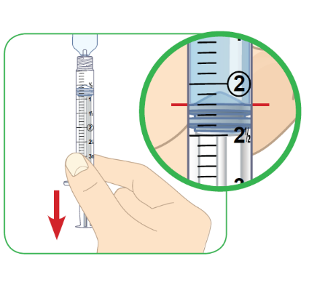
- You must check for air pockets or air bubbles in your 3 mL syringe. See steps 6-8 below on removal of air pockets and air bubbles from the syringe.
- Remove the syringe from the plastic ampoule.

Attach the needle to the syringe.
- Do not over-tighten the needle.
- Do not remove the needle guard.
- Do not touch the needle.

Glass ampoule of water for injection

The glass ampoule is a sealed container.

Before opening the water for injection ampoule, prepare the 3 mL syringe by attaching the needle to it. Do not over-tighten the needle.
- Remove the needle guard.
- Do not touch the needle.

To remove the water for injection, break open the ampoule at the break-point as shown in the picture above.
- Hold the ampoule so that the tip is facing up.
- Use the alcohol swab to clean the break point on the ampoule.
- Hold the bottom of the ampoule in one hand and the top of the ampoule in your other hand.
- Keeping the bottom of the ampoule still, snap the tip off.

Insert the 3 mL syringe into the glass ampoule.
- The glass ampoule should be at a 45 degree angle to the ground.
- The needle should go as far into the ampoule as possible.

With the needle still in the ampoule, pull the plunger up carefully.
- Pull up until the top rim of the plunger lines up with the black 2.2 mL line.
- You must check for air pockets or air bubbles in your 3 mL syringe. See steps 6-8 below on removal of air pockets and air bubbles from the syringe.
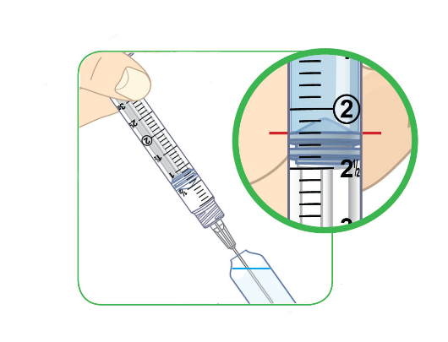

Glass vial of water for injection

The glass vial will have a plastic cap that you should remove, revealing a rubber seal below.
- Do not remove the rubber seal.

Attach the needle to the 3 mL syringe. Do not over-tighten the needle.
- Remove the needle cover.
- Do not touch the needle.
- Pull the plunger down to the 2.2 mL line to draw air into the syringe.

Place the vial on a hard, flat surface.
- Insert the 3 mL syringe needle into the vial, through the rubber seal.
- The needle should be facing down.
- The needle should go all the way into the vial.

Push the plunger all the way down.

With the needle still in the vial, turn the vial and syringe upside down. The needle will now be facing up.
- Do not remove the needle from the vial.

Pull the plunger down carefully
- Pull it down until the top rim of the plunger lines up with the black 2.2 mL line.
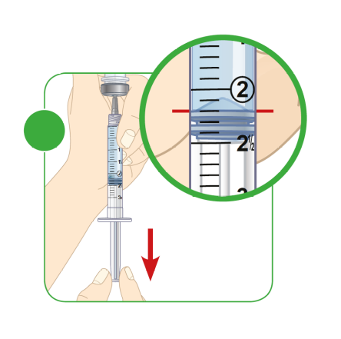

6) No matter whether you have withdrawn water for injection from a vial or ampoule, you must check for air pockets or air bubbles in your 3 mL syringe.
- Sometimes, large spaces of air (air pockets) get caught inside the syringe. You might also see smaller air bubbles in the syringe.
- You must remove an air pocket and air bubbles from the syringe to make sure you get the correct amount of sterile water in the syringe.

7) Remove any air pocket or air bubbles.

Using the glass vial or plastic ampoule
- With the syringe still inserted into the glass vial or plastic ampoule, tap the side of the syringe to move the air pocket/air bubbles to the top of the syringe.
- Carefully push the plunger back up to force the air out of the syringe.

Using the glass ampoule
- Remove the syringe from the ampoule and hold it so that the needle faces up.
- Tap the side of the syringe to move the air pocket/air bubbles to the top of the syringe.
- Carefully push the plunger back up to force the air out of the syringe.

8) Check the amount of water for injection
- If there is less than 2.2 mL of water for injection in the syringe, draw more water for injection into the syringe and repeat the steps 6 and 7 until you have 2.2 mL in the syringe.

9) With 2.2 mL of water for injection in the syringe, remove the syringe from the vial or ampoule.
- Do not move the plunger.
- Do not touch the exposed needle on your syringe as it is sterile, and you may damage the needle or injure yourself.

Step C: Dissolving Myalepta

10) Make sure the vial of Myalepta powder has been out of the refrigerator for at least 10 minutes to reach room temperature.

11) Remove the plastic cap from the vial of Myalepta powder.
- Place the vial on a flat, hard surface.
- Clean the top of the vial with the alcohol wipe.

12) Insert the needle of the 3 mL syringe containing the 2.2 mL of water for injection all the way into the Myalepta vial containing the powder.

13) Hold the vial at 45 degree angle to the table and slowly push the plunger all the way down with your thumb.
- The water for injection should go down the inside wall of the vial.
- All of the water for injection should be injected into the vial.

14) Take the needle out of the vial and throw away the syringe into a sharps disposal container.

15) Mix the powder and water for injection
- Move the vial gently in a circle (swirling motion)
- Until the powder dissolves and the liquid is clear. Do not shake or vigorously mix.
- The solution will take less than 5 minutes to become clear.
When properly mixed, the Myalepta solution should be clear and free of lumps of dry powder, bubbles or foam. Do not use the solution if it is not clear or has bits or lumps in it. Throw it away and start again from step 1.

Step D: Filling the syringe with Myalepta for injection

16) To inject the Myalepta solution, you will use a new injection syringe, which will either be the 0.3 mL, 1.0 mL, or 2.5 mL syringe that was provided to you by your doctor, nurse or pharmacist. Remove the needle cover.
- Do not touch the needle.
- Do not move the plunger.

17) Insert the needle through the centre of the rubber bung, all the way into the vial containing the dissolved Myalepta solution.

18) With the needle in the vial, turn the vial and syringe upside down.

19) Keeping the needle inside the vial, pull the plunger down.
- The top rim of the plunger should line up with the black line on the syringe that matches the amount of Myalepta solution you are going to inject.

20) Check for air pockets and air bubbles.
- If you see an air pocket or any air bubbles, follow the same instructions described in step 7 to remove the air from the syringe.

21) If the syringe contains your correct dose amount of Myalepta solution, remove the needle from the vial.
- Do not move the plunger.
- Do not touch the needle.

Step E: Choose and preparing where to inject

22) Carefully choose where you want to inject Myalepta. You can inject this medicine into the following areas:
- stomach area (abdomen), except for a 5 cm area directly around the belly button
- thigh
- back of the upper arm

If you want to use the same area of the body for each injection, do not use the same spot that you used for your last injection.
- If you inject other medicines, do not inject Myalepta in the same site as you have done for those other medicines.

23) Clean the area where you will inject yourself with a clean alcohol swab and let the skin dry.
- Do not touch the area you have cleaned until you are injecting Myalepta.

Step F: Injecting Myalepta

Important: Myalepta must be injected under the skin (‘subcutaneous’). Do not inject into a muscle.

24) To inject under the skin, pinch the skin with one hand where you are going to inject.

25) With the other hand, hold the syringe like a pencil.

26) Gently insert the needle into the skin at approximately a 45 degree angle to the body.
- Do not insert the needle into a muscle.
- The needle is short in length, and all of the needle should go into the skin at a 45 degree angle.

27) Gently use your thumb to push the plunger all the way down.
- Inject all of the medicine.
- If there is medicine left in the syringe, you have not had your full dose.

28) Remove the syringe from the skin.

Step G: Throwing away used materials

29) Throw away the two used syringes and all caps, vials, or ampoules in the sharps disposal container straight away.
- Talk to your doctor, nurse or pharmacist about correct disposal of your sharps disposal container once it becomes full. There might be local regulations for this.

Important
- Do not use the syringes more than once. Use new syringes each time.
- The vials may remain almost completely filled with product after withdrawal of the required dose. Remaining solution should be discarded after use.
- Do not dissolve another dose of Myalepta powder with any ampoule or vial containing unused remaining water for injection. This unused water for injection should be disposed of in your sharps container. Always use a new ampoule or vial of water for injection each time when preparing to dissolve Myalepta powder.
- Do not recycle the syringes, caps, or sharps disposal container, or throw them into household waste.
- Always keep the sharps disposal container out of reach of children.

